**PART I**

Create an Oracle Database and connect to it.

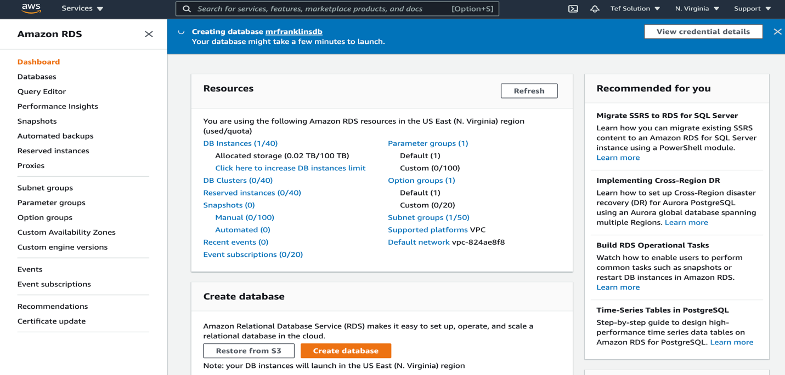

🡪 Choose Standard create:

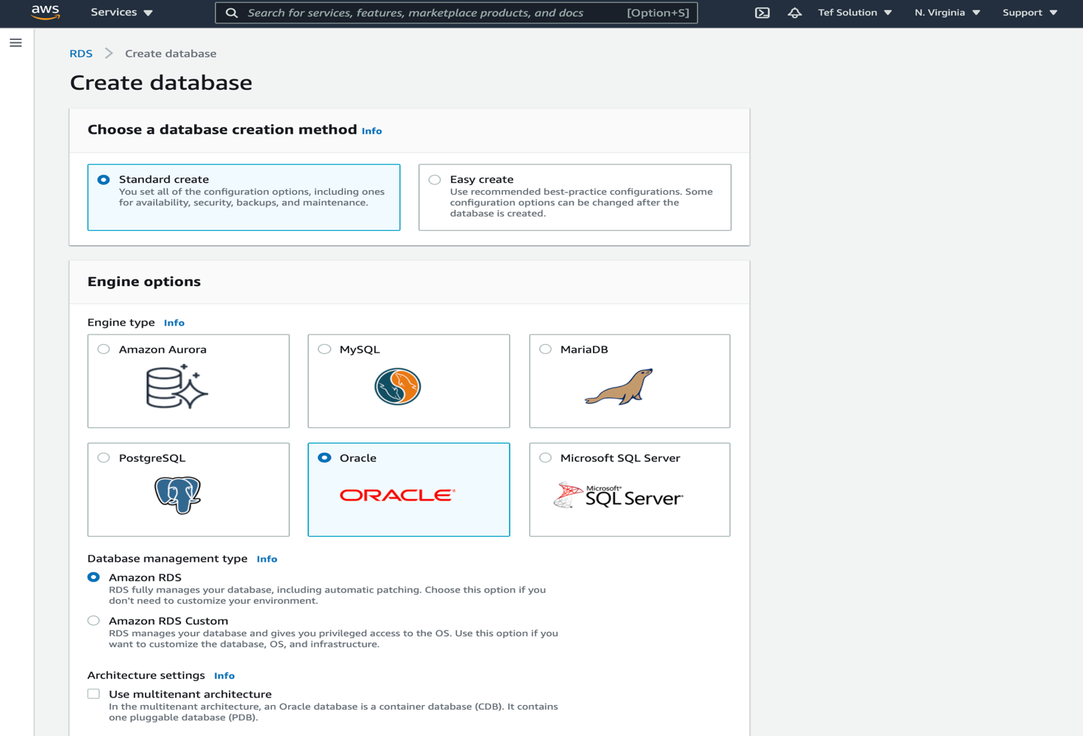

DB Instance identifier: mrfranklinsOracleDB

Password: Mrfranklins

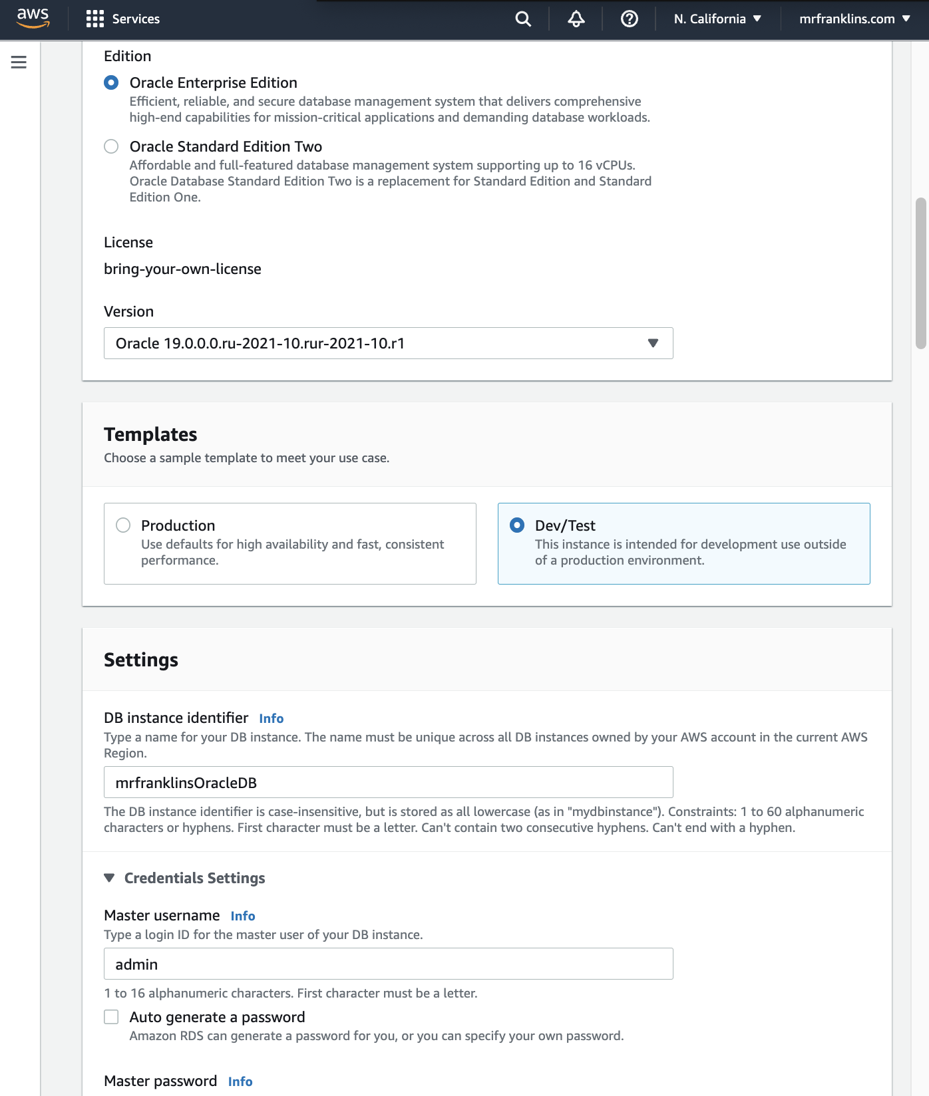

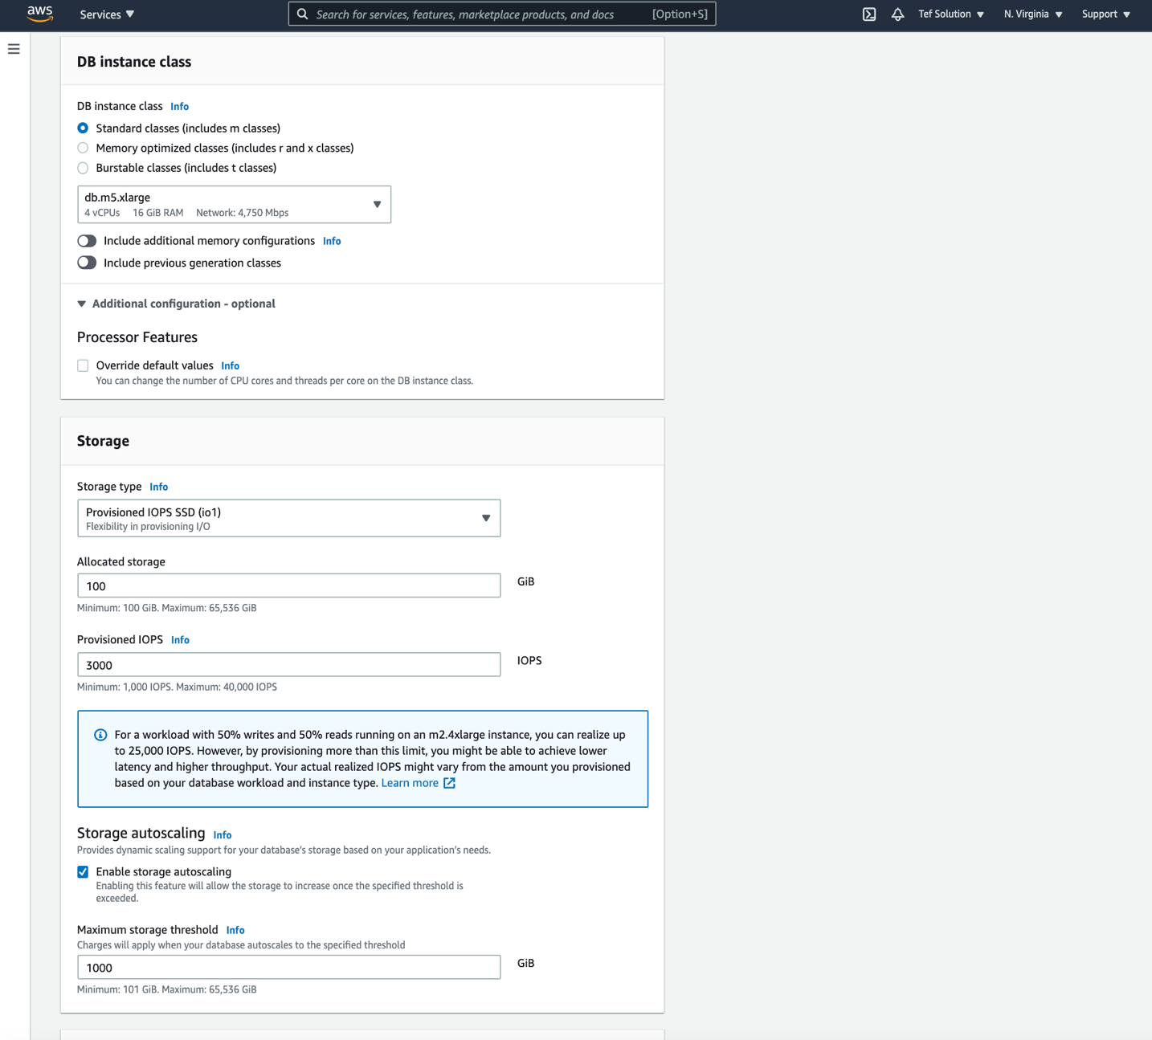

🡪 Do not create standby

🡪 Public access = Yes

🡪 WebDMZ Security Group

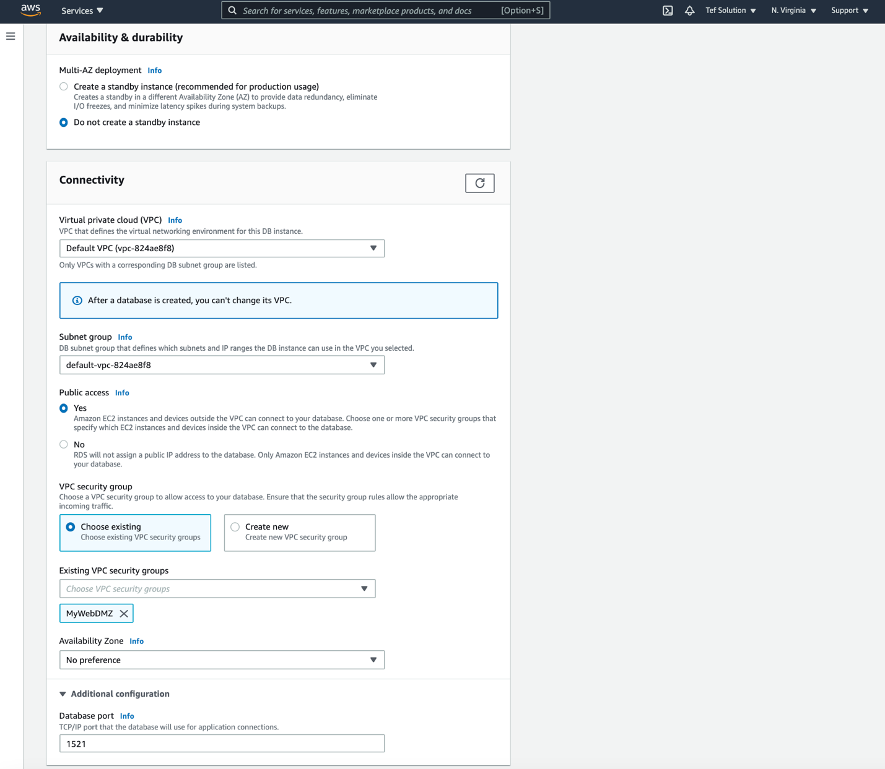

Uncheck: Enable automated backups

Uncheck: Enable encryption

Uncheck: Enable Performance Insights

Uncheck: Enable Enhanced monitoring

Uncheck: Enable deletion protection

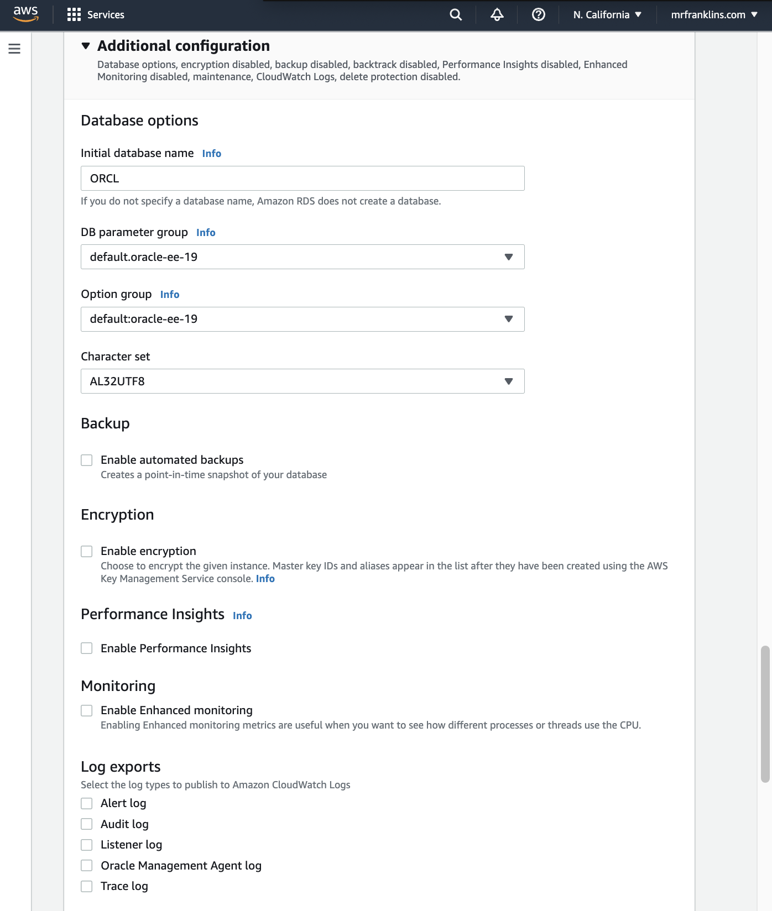

NB: If you do not specify a name for the “**initial Database name”** above, a database will be create with the default name “**ORCL**”. You can leave it blank.

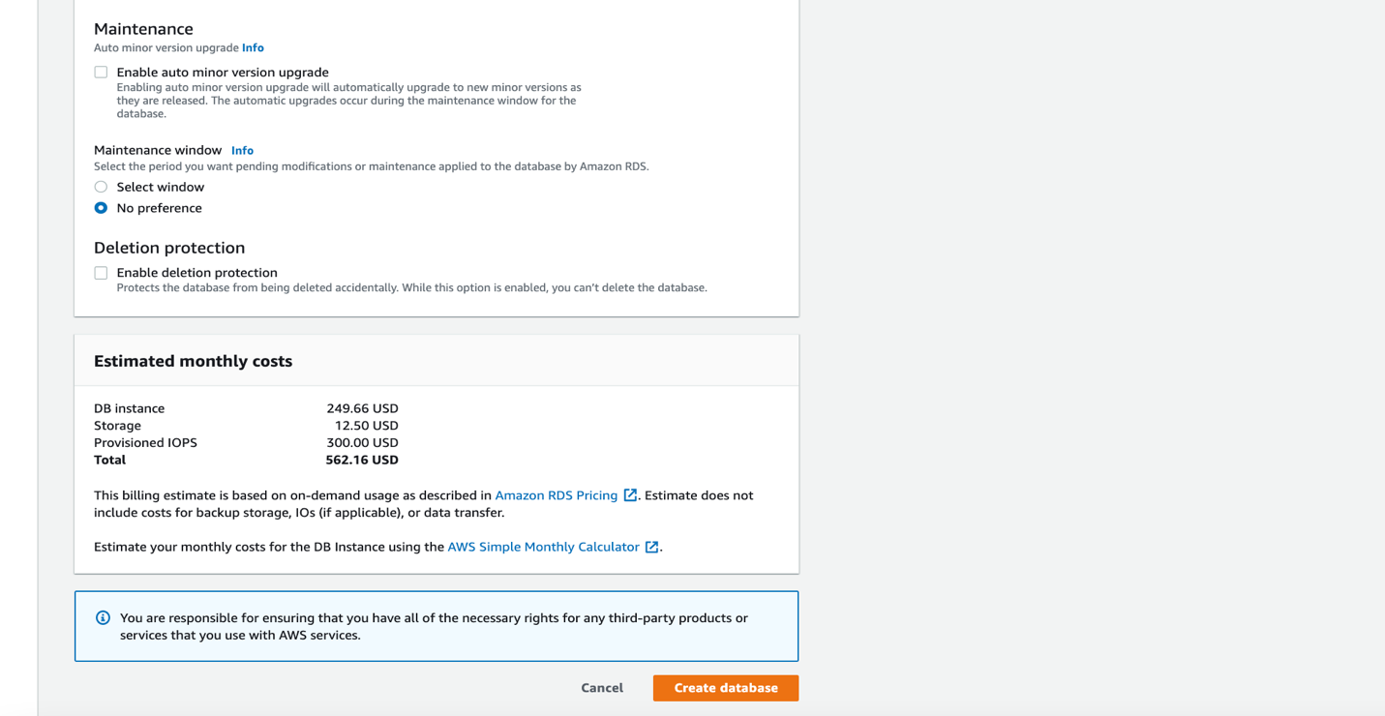

🡪 Click create database!

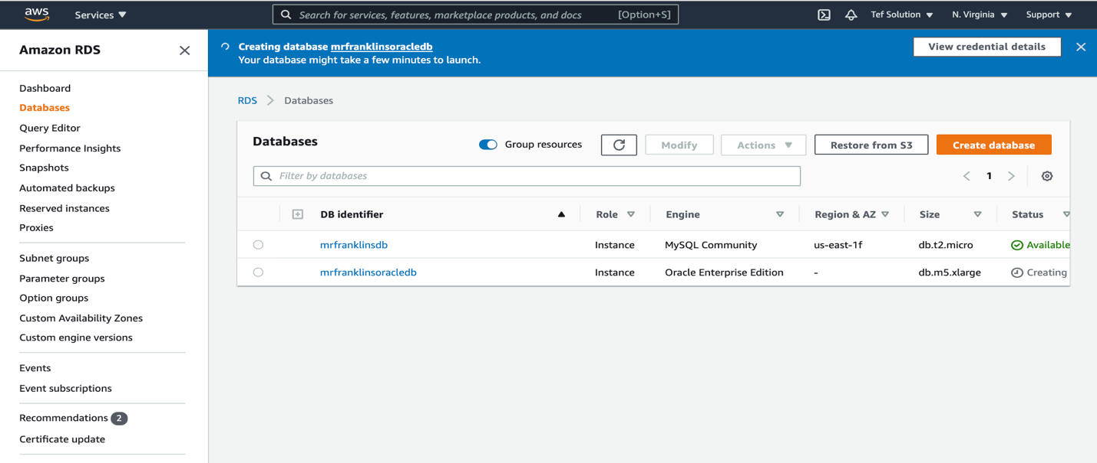

Modify Security Group: (WebDMZ)

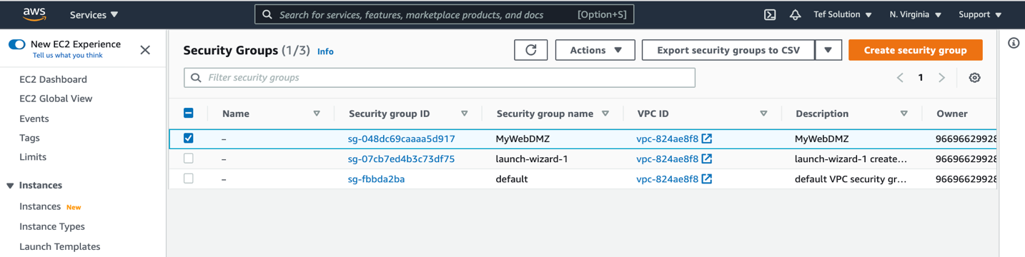

Click on the WebDMZ SG.

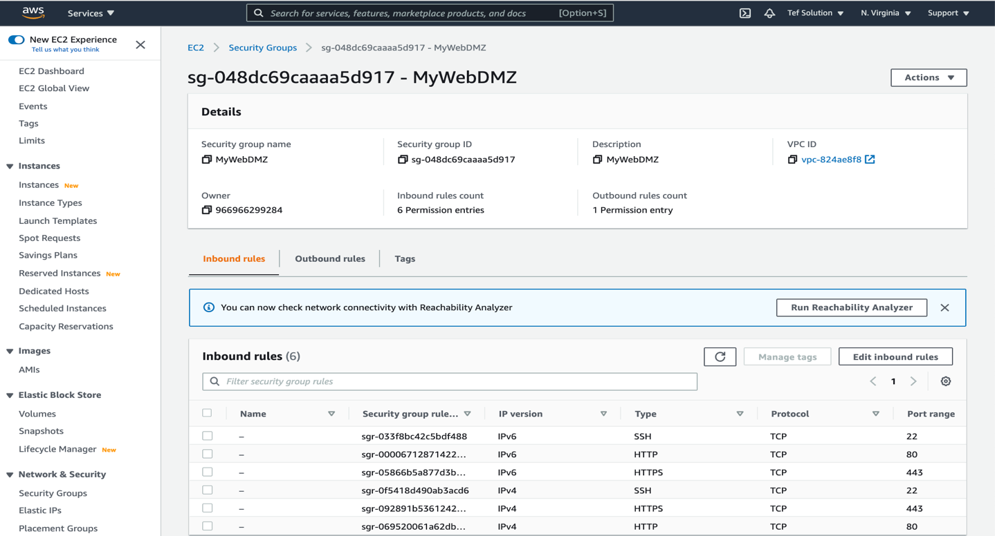

🡪 edit inbound rules

🡪 Add 2 rules:

1. Type: All traffic

Source: Anywhere IPV4

1. Type: All traffic

Source: Anywhere IPV6

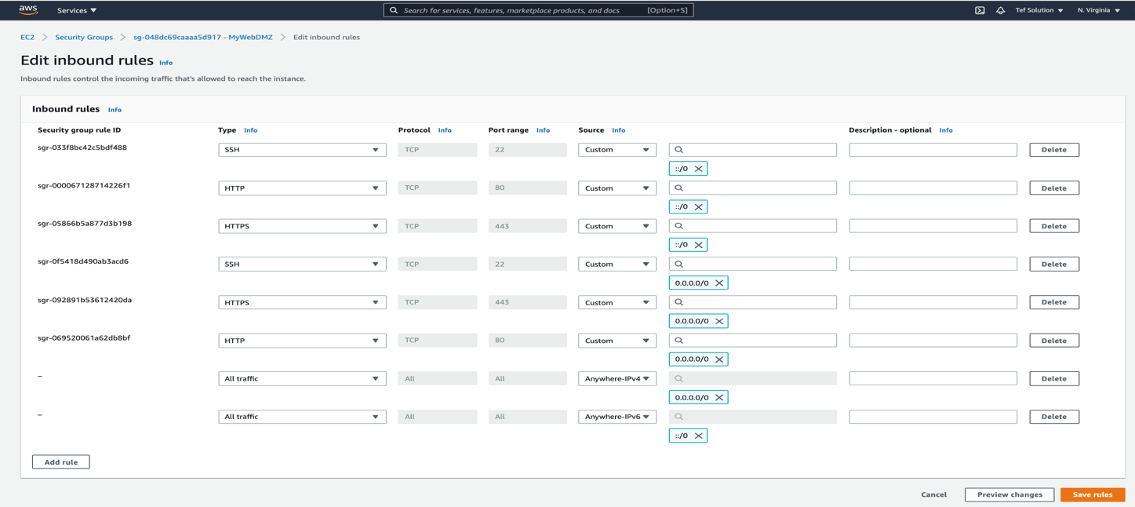

And save!

YOU ARE DONE CREATING AN ORACLE DATABASE IN THE CLOUD!!!!!!

**Now connect to that Oracle DB using DBeaver Application!**

Open the DBeaver Application.

Click on the plug with the plus (+) sign and choose the Oracle RDS flavor!

Click: Next!

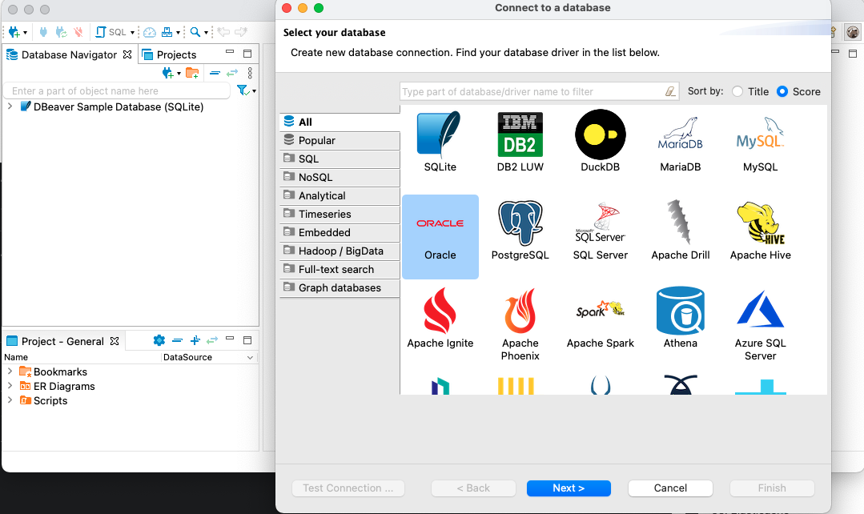

NB:

* Your hostname is your endpoint name. You can find it on the database under connectivity & security.
* Your Database is ORCL. on the database under Configuration.
* Change Service Name to SID.
* Input Username and Password = mfgoracle

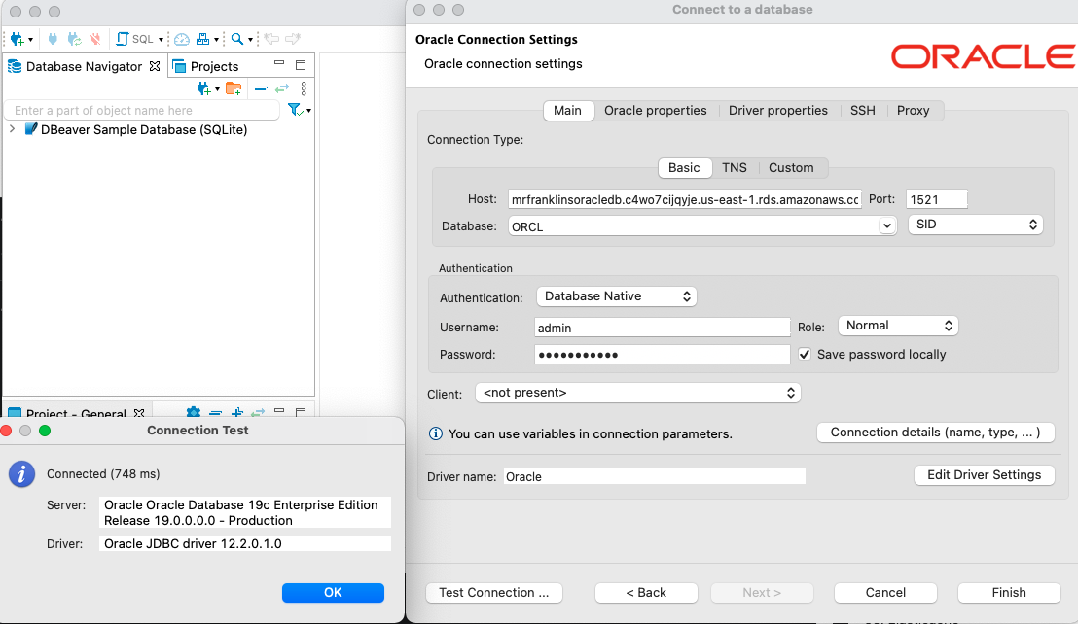

🡪 Click on test Connectivity.

🡪 Click on finish after successfully testing connectivity.

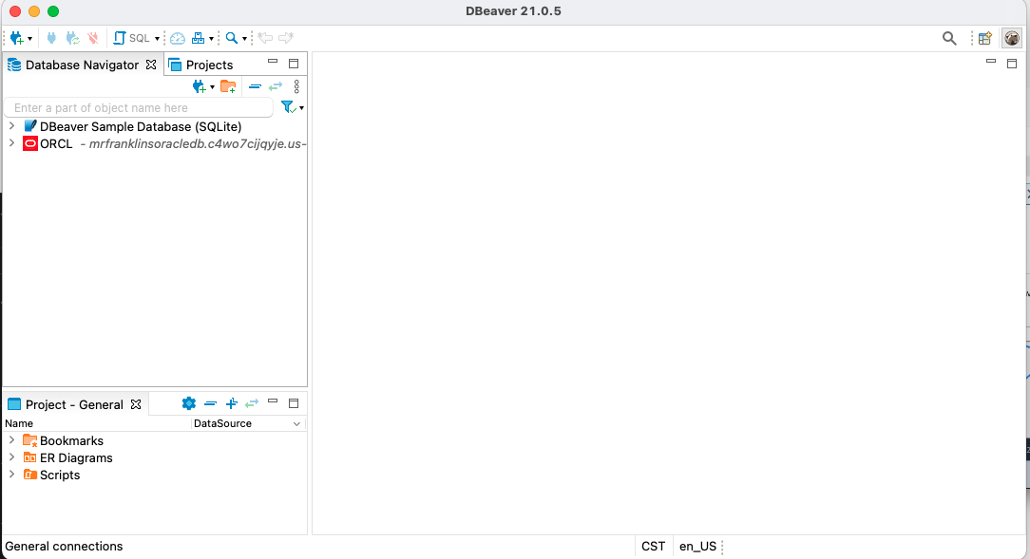

🡪 Right click on the database and open SQL Editor.

Run below queries.

**Find Database name:**

SELECT name FROM v$database;

**Find Database status:**

SELECT INSTANCE_NAME, STATUS, DATABASE_STATUS FROM V$INSTANCE;

**Find Tables in your database:**

SELECT * FROM all_tables ORDER BY table_name;

**Create a table:**

CREATE TABLE mrfranklins.student

( supplier_id number(10) NOT NULL,

supplier_name varchar2(50) NOT NULL,

address varchar2(50),

city varchar2(50),

state varchar2(25),

zip_code varchar2(10)

);

Select owner, table_name from all_tables WHERE OWNER = 'MRFRANKLINS' AND TABLE_NAME='STUDENT';

**Create a User in your Database and grant DBA permission to that user.:**

**CREATE** **USER** Houston **IDENTIFIED** **BY** "houston" account unlock;

**SELECT** username **from** dba_users **WHERE** username ='HOUSTON';

**GRANT** DBA **TO** HOUSTON;

**Try connecting as User Houston to the Oracle database as shown below:**

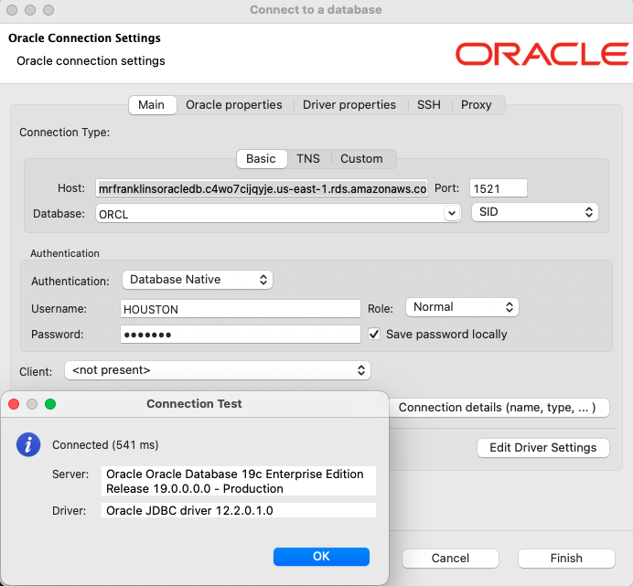

Drop User or just delete the entire Oracle database!!

**DROP** **USER** HOUSTON;

**SELECT** username **from** dba_users **WHERE** username ='HOUSTON';

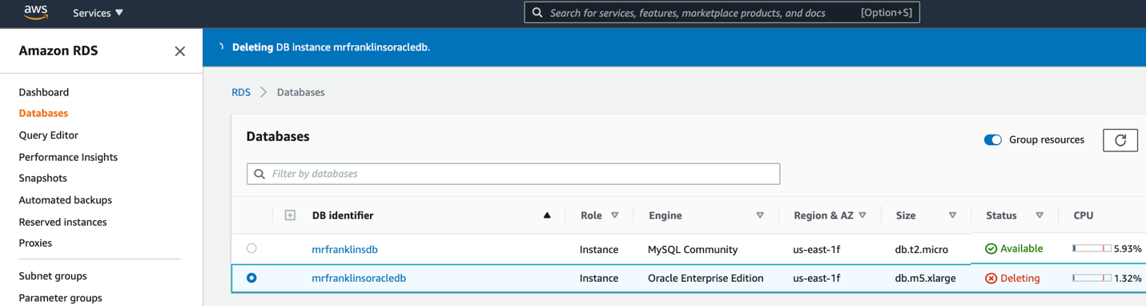

### **CONGRATULATIONS!!**

### **YOU’VE SUCCESSFULLY CREATED AND CONNECTED TO YOUR ORACLE DATABASE IN THE CLOUD**

REMEMBER TO DELETE YOUR DATABASE: