Demo – S3 Versioning

================================================

Upload a file (mfgtech-accesskeys.csv).

* Click on **Upload**

It will lead you to below screen where you can add files or even folders to upload in the bucket.

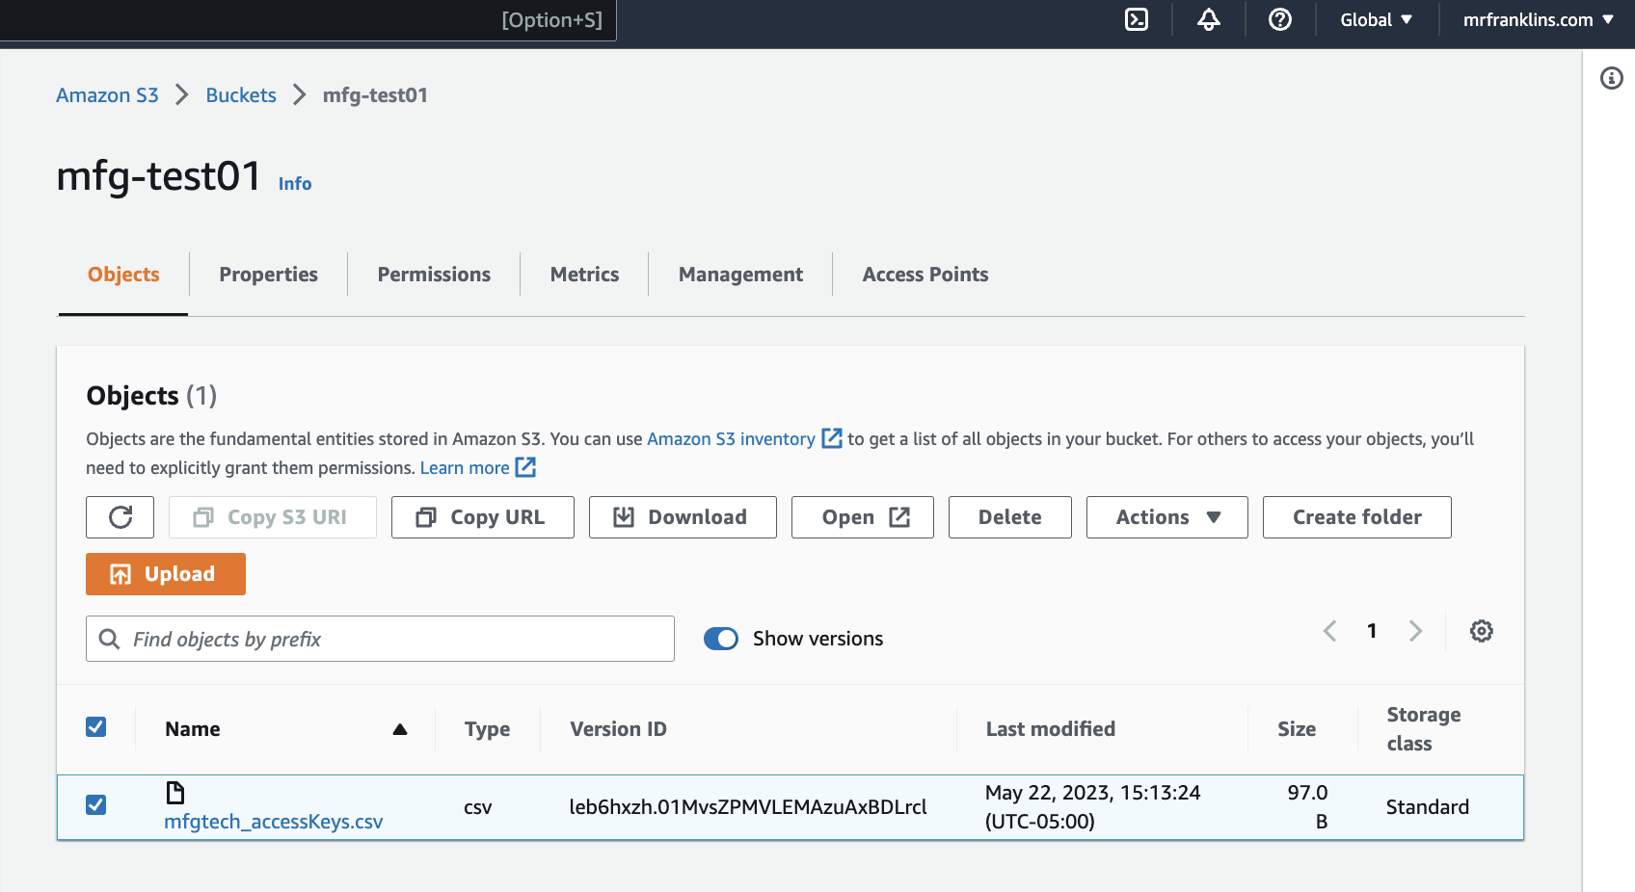

NB: Upload the same file twice with the same name, in the same bucket in order to create a different version

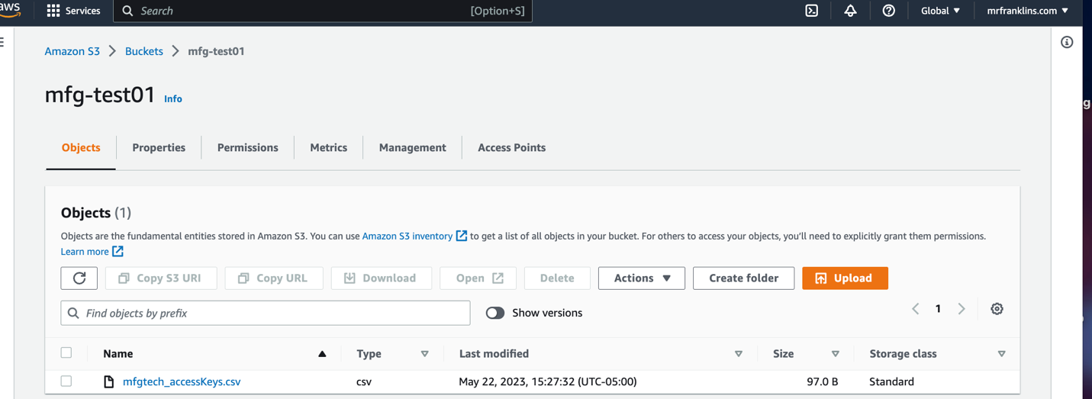

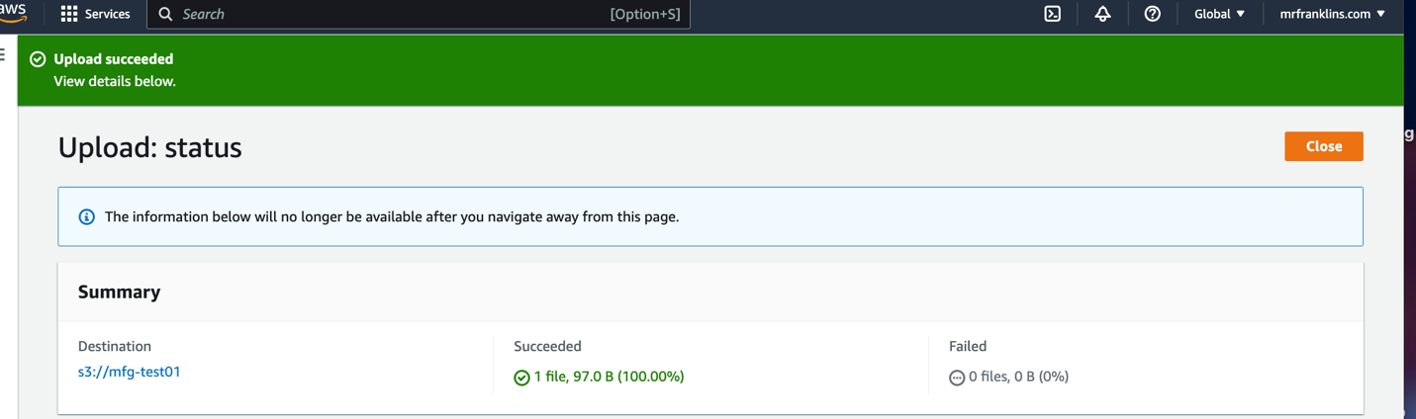

* Click on show Versions

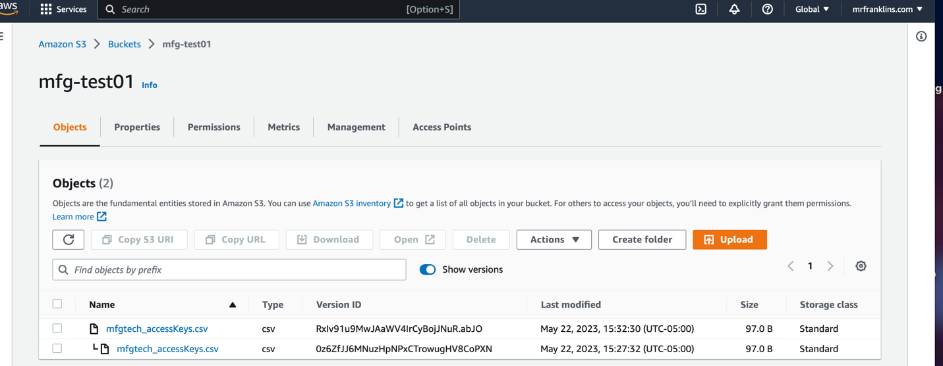

* Select object (mfgtech-accesskeys.csv)
* Uncheck show version
* Click on and delete the file.

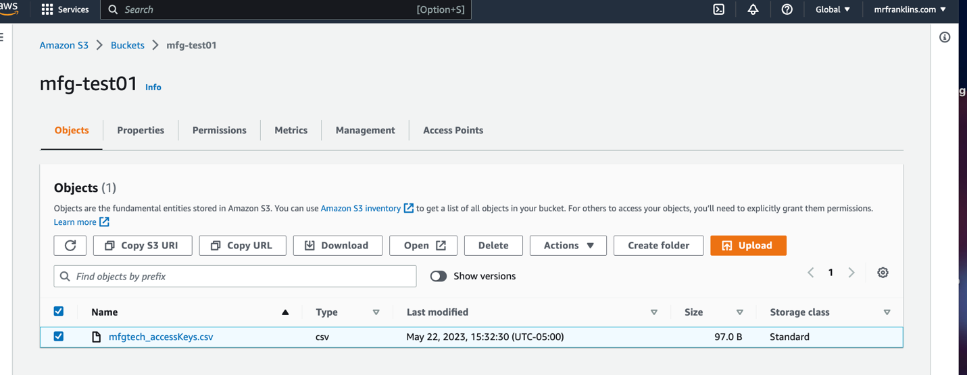

* File Deleted.

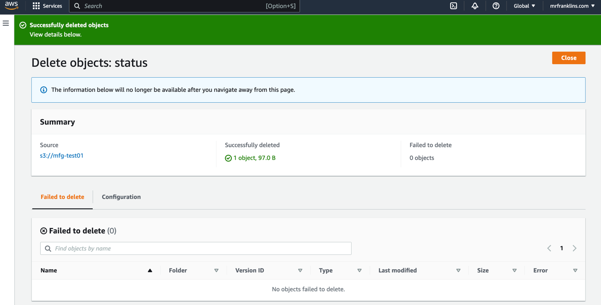

* File Gone.

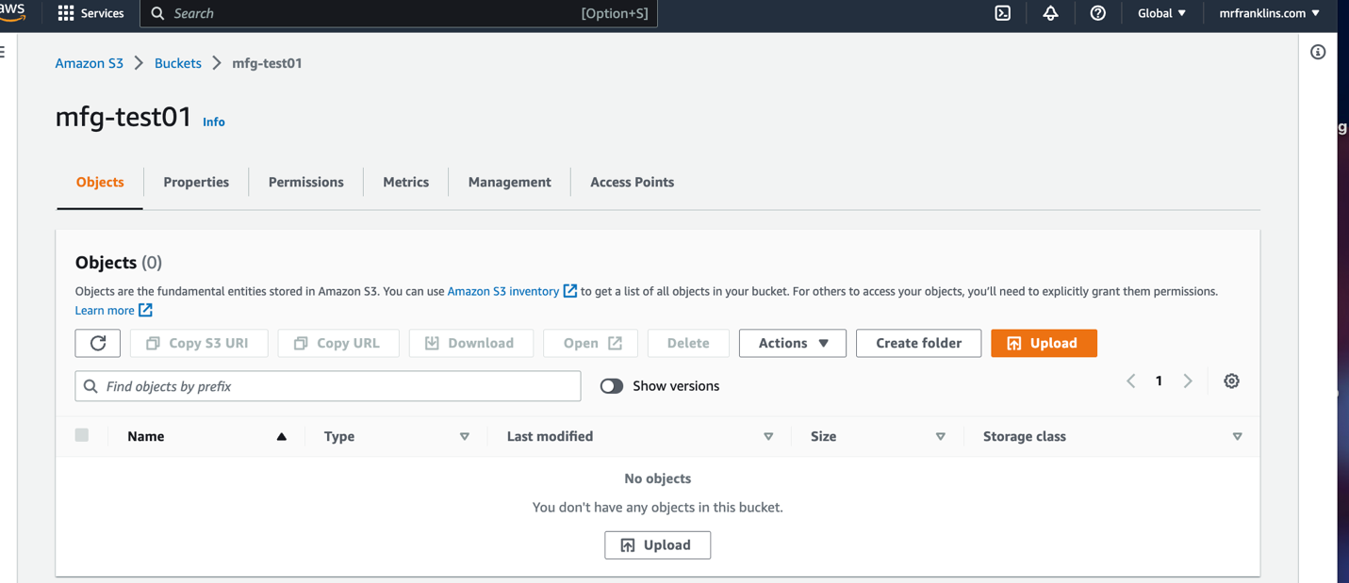

* Click on show versions

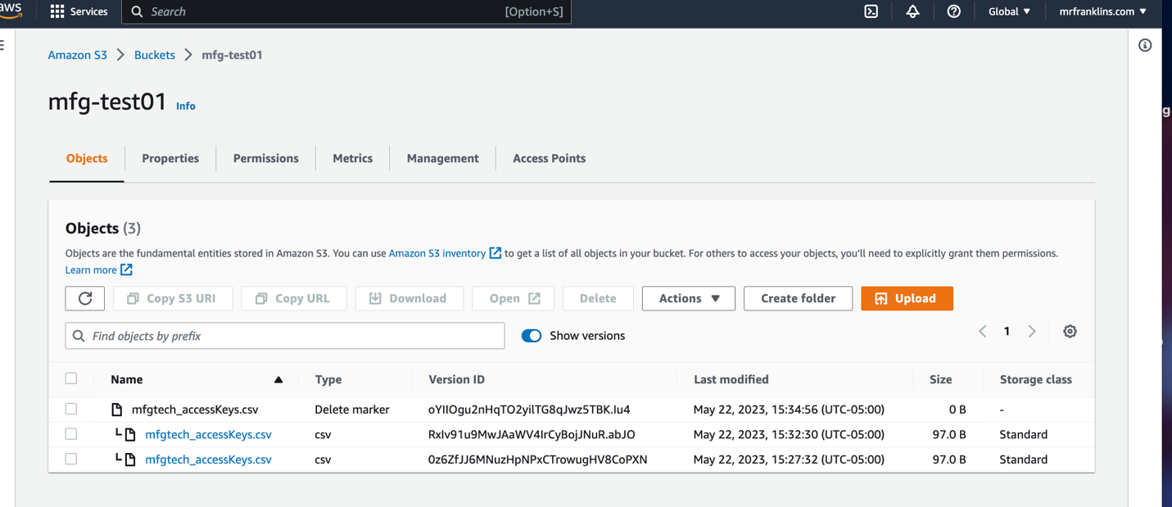

NB: You can delete a delete marker by specifying the version ID in the delete object request. Removing a delete marker makes an older version current

* Select the Delete Marker version and click on delete.

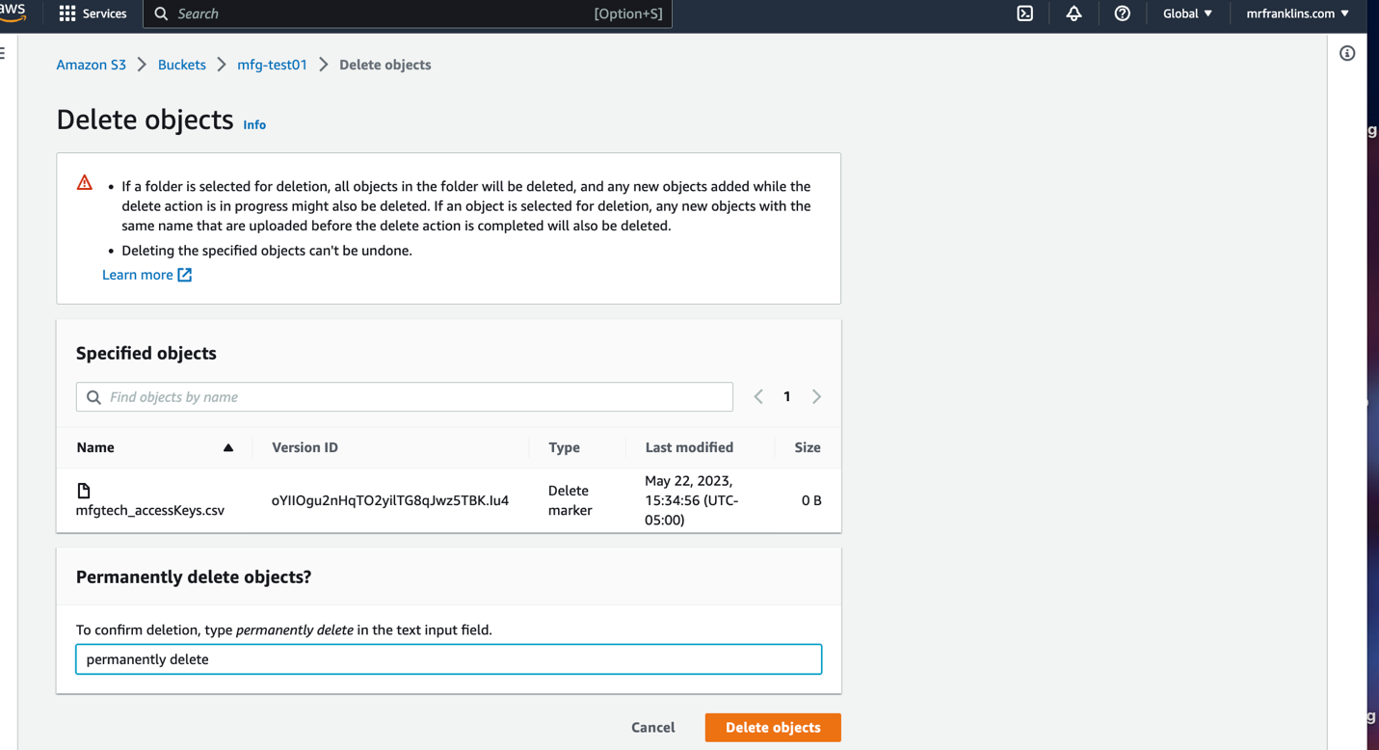

* File has been restored.

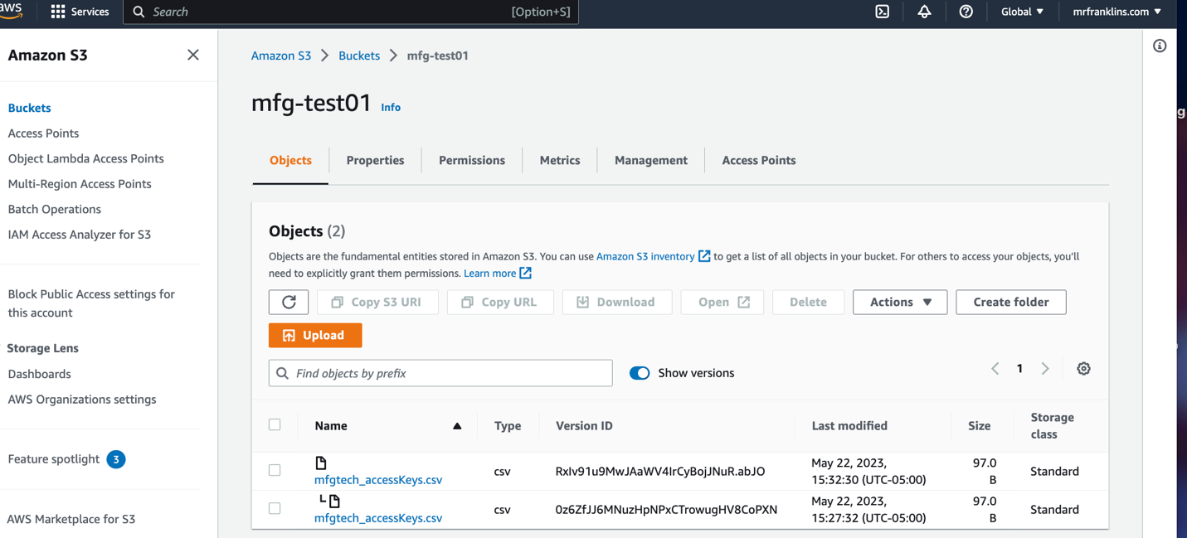

NB: If you delete both versions. Then of course both file versions will be gone!