Provisioning A Two-Tier Infrastructure Using the AWS CLI
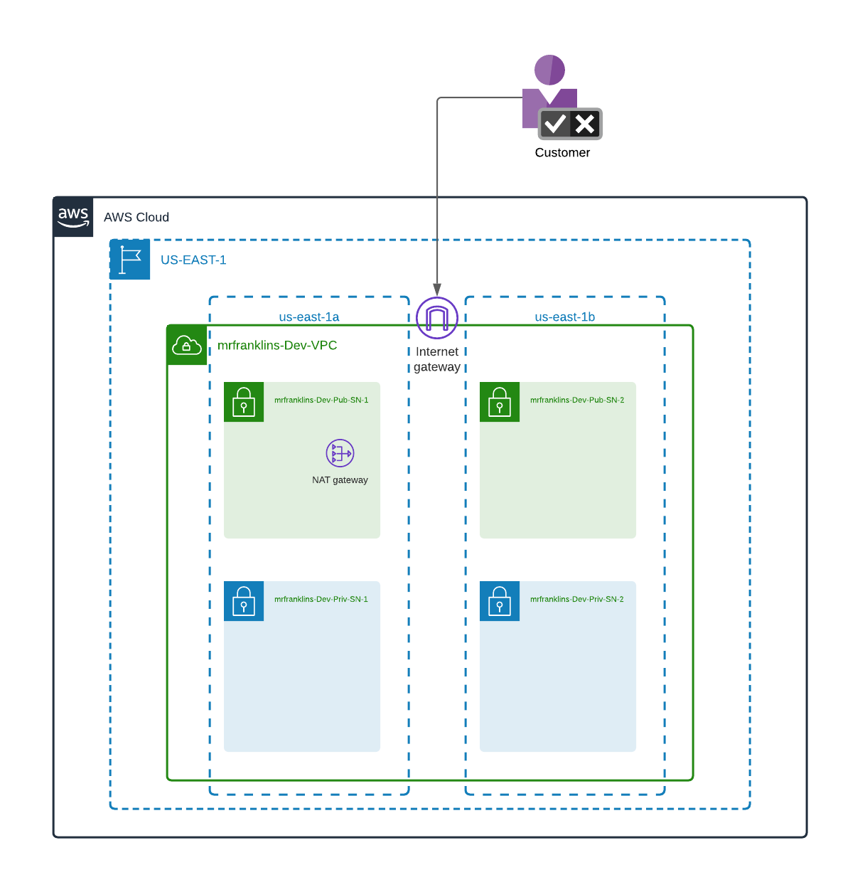

Sample Queries:
https://dev.to/mariehposa/how-to-create-vpc-subnets-route-tables-security-groups-and-instances-using-aws-cli-14a4#internet-gateway

CONFIGURE YOUR CLI:
franklin@mrfranknsProMac ~ % aws configure list
Name Value Type Location
---- ----- ---- --------
profile <not set> None None
access_key ****************MJYR shared-credentials-file
secret_key ****************JRdH shared-credentials-file
region us-west-2 config-file ~/.aws/config

NB1: Make sure you Environment is configured to the same region where you are launching (deploying) your resources. E.g., resources below are being launched in us-west-2 and the environment is configured to us-west-2 as well as seen above.

- VPC Creation:
CMD:​
aws ec2 create-vpc --cidr-block 100.0.0.0/16 --region us-west-2 --tag-specifications 'ResourceType=vpc, Tags=[{Key=Name,Value=mrfranklins-Dev-VPC}]'

NB: Make sure Press enter 3 times only. Then Kill the command (ctrl C). The VPC will be created
Output
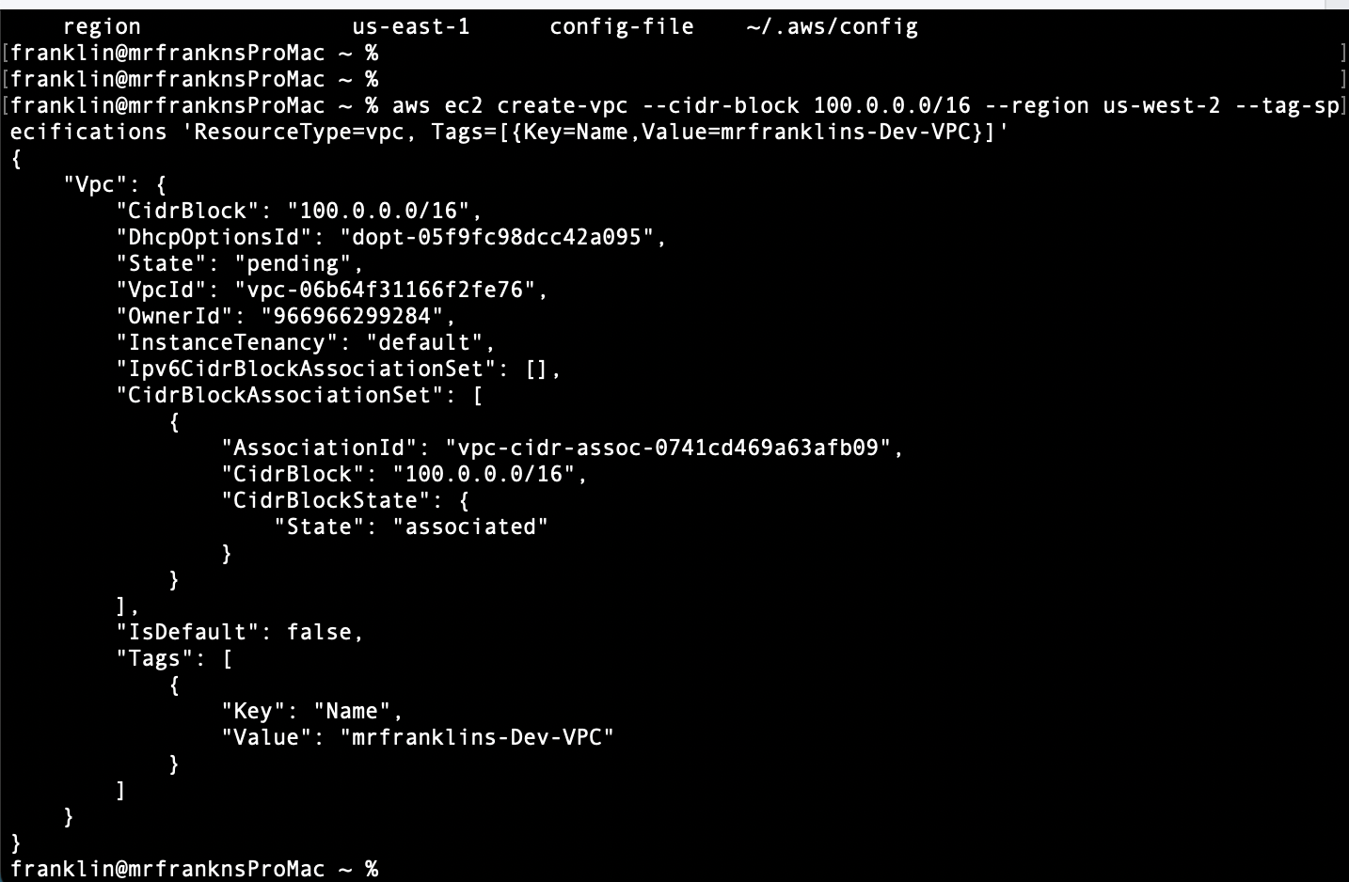
- Create 2 Private Subnets:
a) Create Private subnet 1​ (​mrfranklins-Dev-Private-Subnet-1​)
CMD:​​ Make sure the VPC ID below matches with the new VPC ID created from above.

aws ec2 create-subnet --vpc-id vpc-06b64f31166f2fe76 --cidr-block 100.0.1.0/24 --tag-specifications 'ResourceType=subnet, Tags=[{Key=Name,Value=mrfranklins-Dev-Private-Subnet-1}]' --region us-west-2 --availability-zone us-west-2a

Output
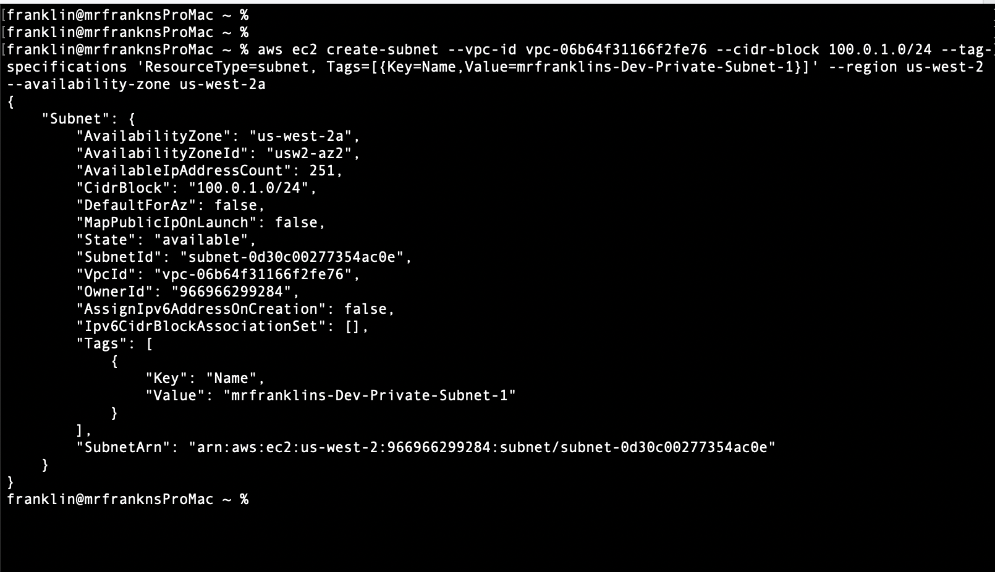

b) Create Private subnet2(​mrfranklins-Dev-Private-Subnet-2)​
CMD:​​

aws ec2 create-subnet --vpc-id vpc-06b64f31166f2fe76 --cidr-block 100.0.2.0/24 --tag-specifications 'ResourceType=subnet, Tags=[{Key=Name,Value=mrfranklins-Dev-Private-Subnet-2}]' --region us-west-2 --availability-zone us-west-2b

Output
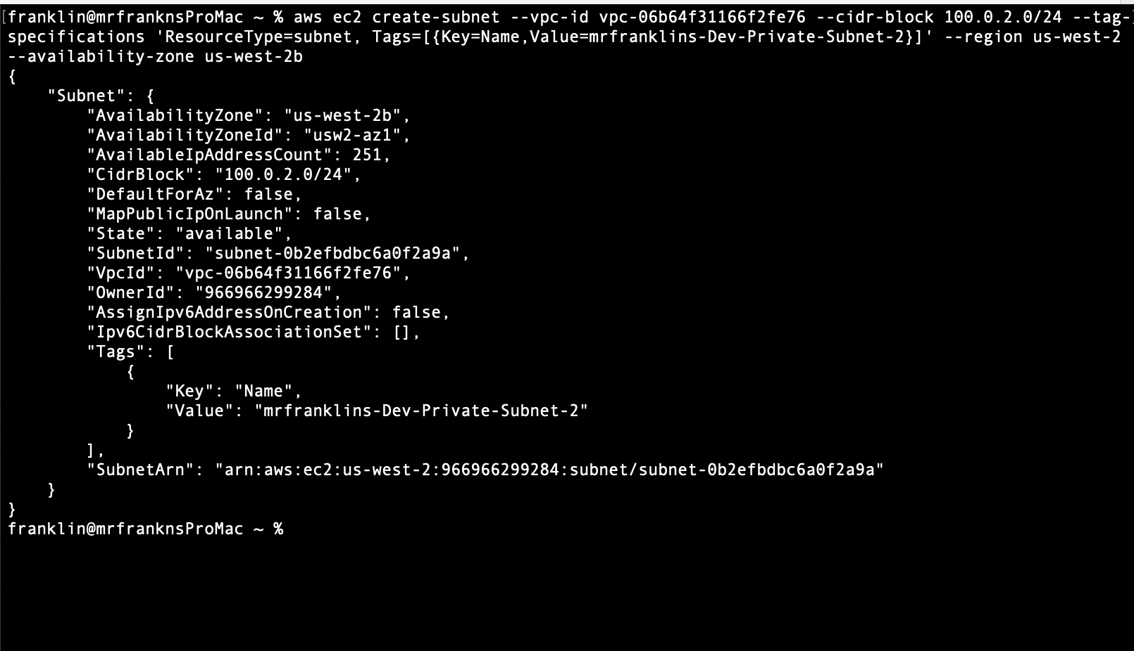
3) ​Create 2 Public Subnets:
a) Create Public Subnet 1 (mrfranklins-Dev-Public-Subnet-1)
CMD:

​​ aws ec2 create-subnet --vpc-id vpc-06b64f31166f2fe76 --cidr-block 100.0.3.0/24 --tag-specifications 'ResourceType=subnet, Tags=[{Key=Name,Value=mrfranklins-Dev-Public-Subnet-1}]' --region us-west-2 --availability-zone us-west-2a

Output
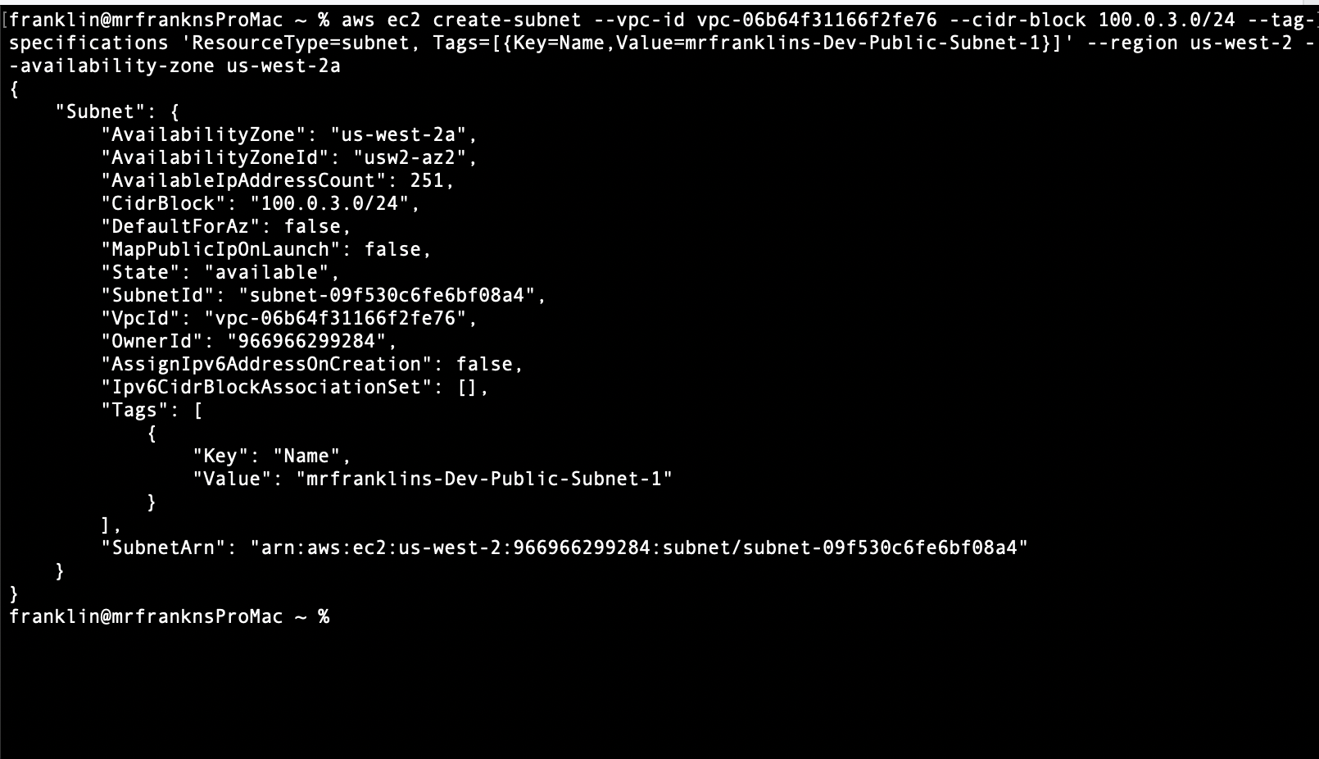
b) Create Public Subnet 2 (mrfranklins-Dev-Public-Subnet-2)
CMD:​
aws ec2 create-subnet --vpc-id vpc-06b64f31166f2fe76 --cidr-block 100.0.4.0/24 --tag-specifications 'ResourceType=subnet, Tags=[{Key=Name,Value=mrfranklins-Dev-Public-Subnet-2}]' --region us-west-2 --availability-zone us-west-2b

Output
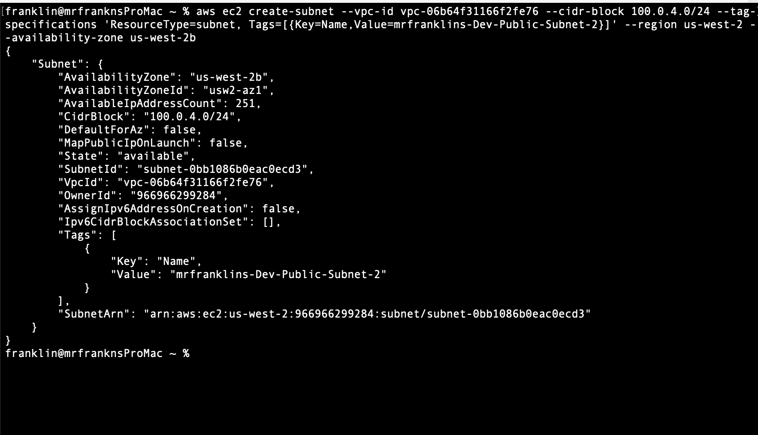
4) ​Create 2 Route tables (Private and Public)
a) Create Private Route table (mrfranklins-Dev-Private-RT)
CMD:​
aws ec2 create-route-table --vpc-id vpc-06b64f31166f2fe76 --region us-west-2
Output
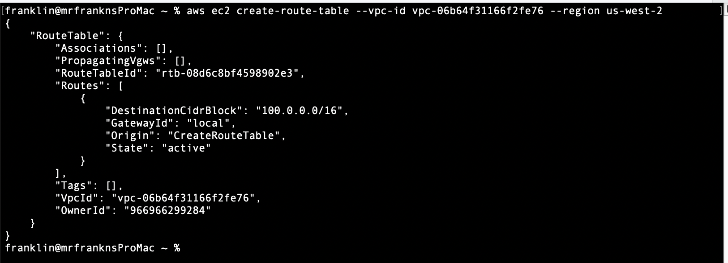
b) Create Public Route table
CMD:​ ​
aws ec2 create-route-table --vpc-id vpc-005fbf43006b6893b --region us-west-2

Output
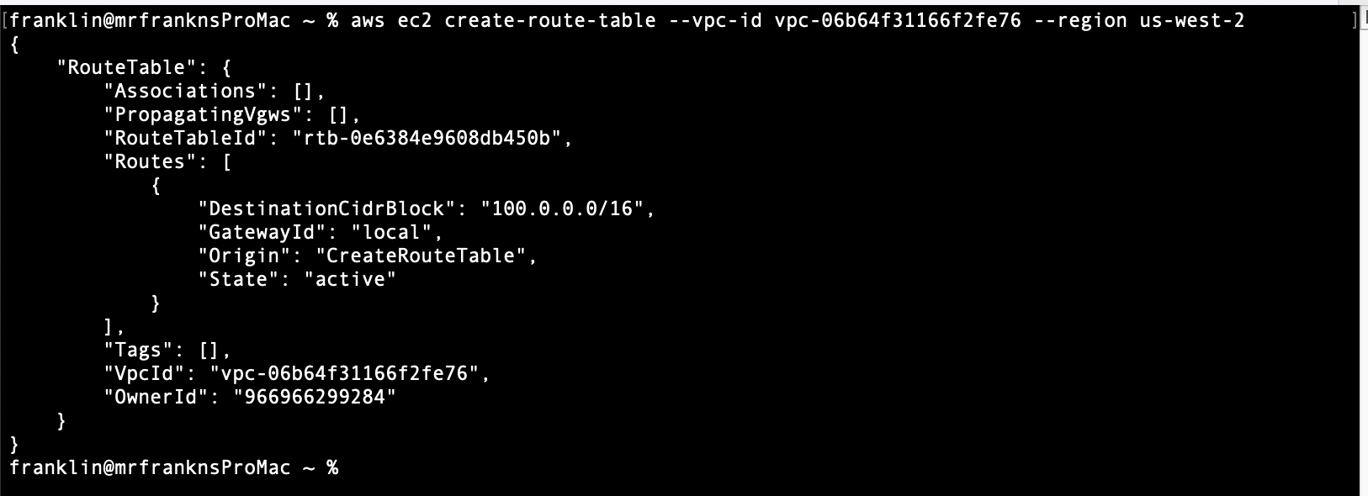
c) Describe your route tables so you can get the VPC ID’s in combination with the route table ID’s, you then use that to give a name tag to your Route Tables.
CMD:​ ​
aws ec2 describe-route-tables --filters "Name=vpc-id, Values=vpc-06b64f31166f2fe76" --region us-west-2
Output
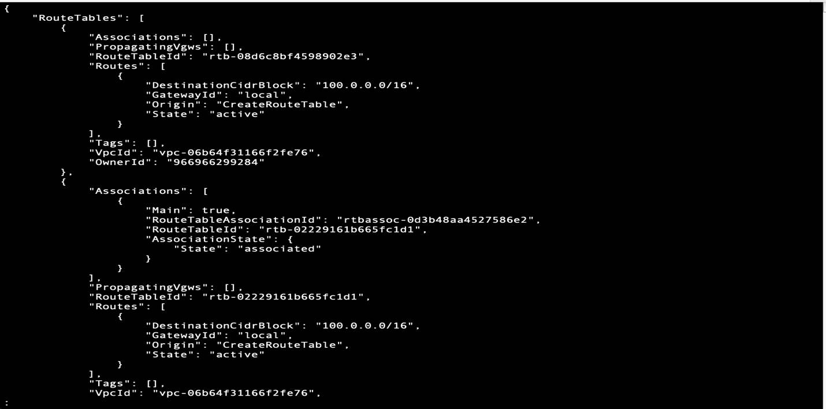

i) Give a name tag to Private Route Table (mrfranklins-Dev-Private-RT​)
CMD​:​

​ aws ec2 create-tags --resources rtb-08d6c8bf4598902e3 --tags 'Key=Name, Value=mrfranklins-Dev-Private-RT' --region us-west-2

Output

ii) Give a name tag to Public Route Table (mrfranklins-Dev-Public-RT​)
CMD:​

​ aws ec2 create-tags --resources rtb-02229161b665fc1d1 --tags 'Key=Name, Value=mrfranklins-Dev-Public-RT' --region us-west-2

Output
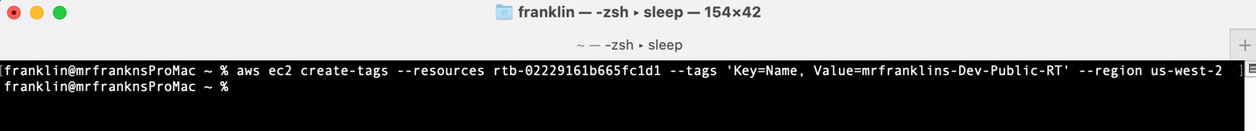
5) ​We need to now Associate our Private Subnets with Private Route table and Public Subnets with Public Route Table.
A) Associate Private subnets with Private route table (But first let’s describe the subnets so we get the ID’s)
i) Describe Subnets first to get Subnet ID’s
NB1: Remember to copy and use your private RT above (rtb-08d6c8bf4598902e3):
aws ec2 describe-route-tables --filters "Name=vpc-id, Values=vpc-06b64f31166f2fe76" --region us-west-2

NB1: Remember to review the Subnets described below and only associate private subnets to private Route Tables.

CMD:​ ​
aws ec2 describe-subnets --filters "Name=vpc-id, Values=vpc-06b64f31166f2fe76" --region us-west-2

Output
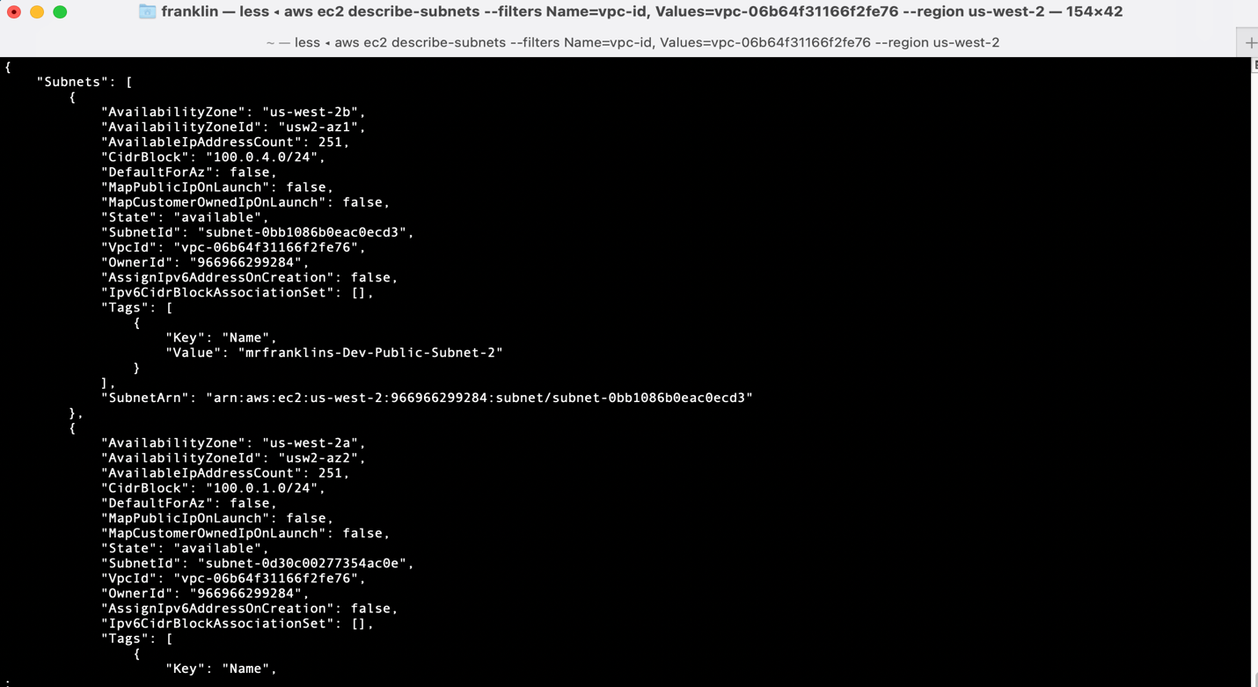

ii) Associate Private subnets with Private Route table
CMD Private Subnet 1:​ ​
aws ec2 associate-route-table --route-table-id rtb-08d6c8bf4598902e3 --subnet-id subnet-0d30c00277354ac0e --region us-west-2
Output
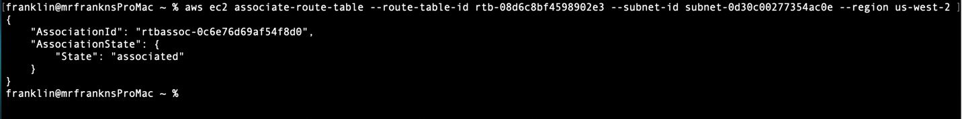

CMD Private Subnet 2​:​
​ aws ec2 associate-route-table --route-table-id rtb-08d6c8bf4598902e3 --subnet-id subnet-0b2efbdbc6a0f2a9a --region us-west-2
Output
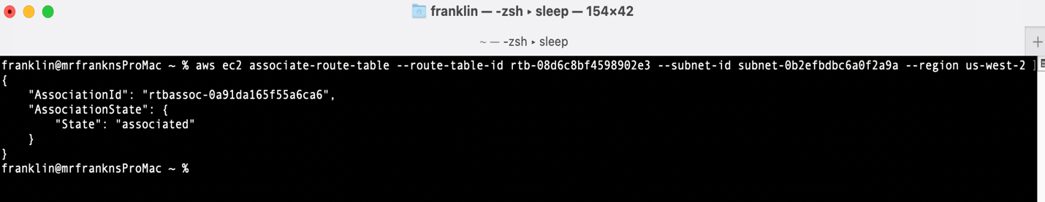

iii) ​​Associate Public subnets with Public Route table
NB1: Remember to copy and use your public RT above (rtb-02229161b665fc1d1):
aws ec2 describe-route-tables --filters "Name=vpc-id, Values=vpc-06b64f31166f2fe76" --region us-west-2

NB: Remember to review the Subnets described above and only associate public subnets to public Route Tables.
aws ec2 describe-subnets --filters "Name=vpc-id, Values=vpc-06b64f31166f2fe76" --region us-west-2
CMD Public Subnet 1:​
aws ec2 associate-route-table --route-table-id rtb-02229161b665fc1d1 --subnet-id subnet-09f530c6fe6bf08a4 --region us-west-2

Output
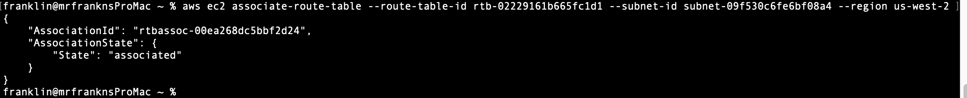

CMD Public Subnet 2​: ​
aws ec2 associate-route-table --route-table-id rtb-02229161b665fc1d1 --subnet-id subnet-0bb1086b0eac0ecd3 --region us-west-2

Output
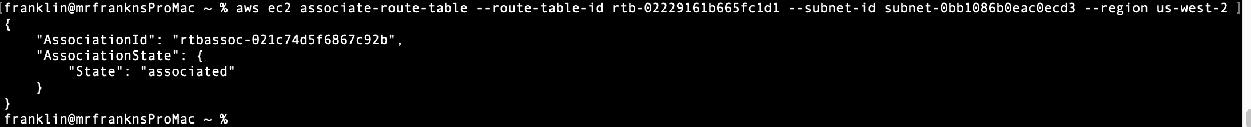

6) ​Create an Internet Gateway for mrfranklins-Dev-VPC, call it (mrfranklins-Dev-VPC-IGW)
CMD:​ ​
aws ec2 create-internet-gateway --tag-specifications 'ResourceType=internet-gateway,Tags=[{Key=Name,Value=mrfranklins-Dev-VPC-IGW}]'

Output
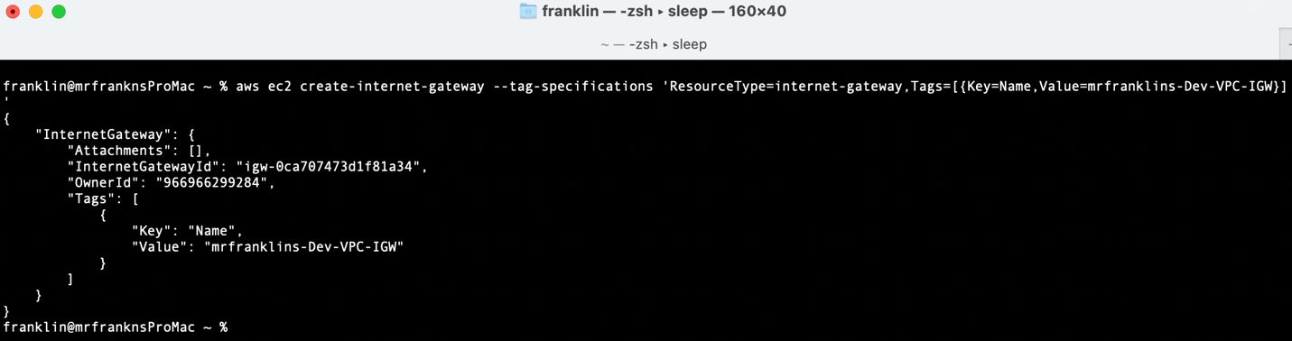

A) Attach Internet Gateway to VPC but first describe your VPC’s
i) Describe VPC’s

CMD:​
​aws ec2 describe-vpcs --region us-west-2

Output
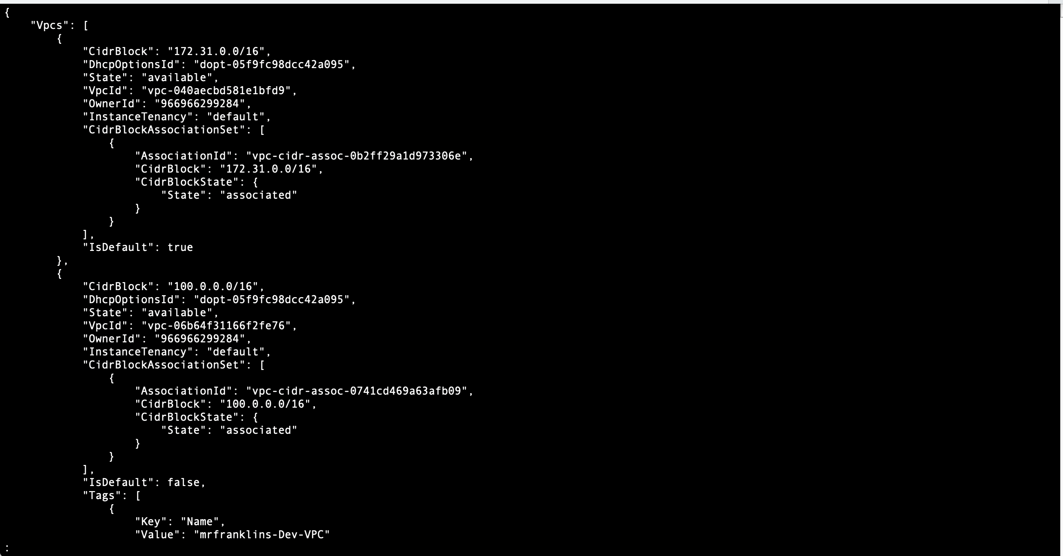

ii) Attach Internet Gateway to mrfranklins-Dev-VPC
NB1: Remember to replace the vpc-id with the newly created mrfranklins-Dev-VPC and the newly created igw id below.

CMD:​
aws ec2 attach-internet-gateway --vpc-id vpc-005fbf43006b6893b --internet-gateway-id igw-0d9768aaeb39960c4 --region us-west-2
Output
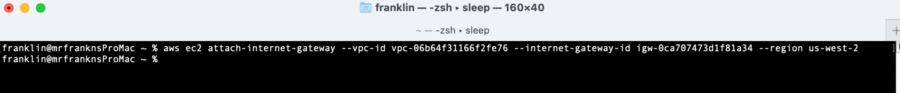

7) ​Create a route in the route table that points all traffic (​0.0.0.0/0​) to the Internet gateway.
i) Describe the route tables again to get the public route table ID which you’ll need for when creating the additional route.
CMD:​
​aws ec2 describe-route-tables --filters "Name=vpc-id, Values=vpc-005fbf43006b6893b" --region us-west-2

Output
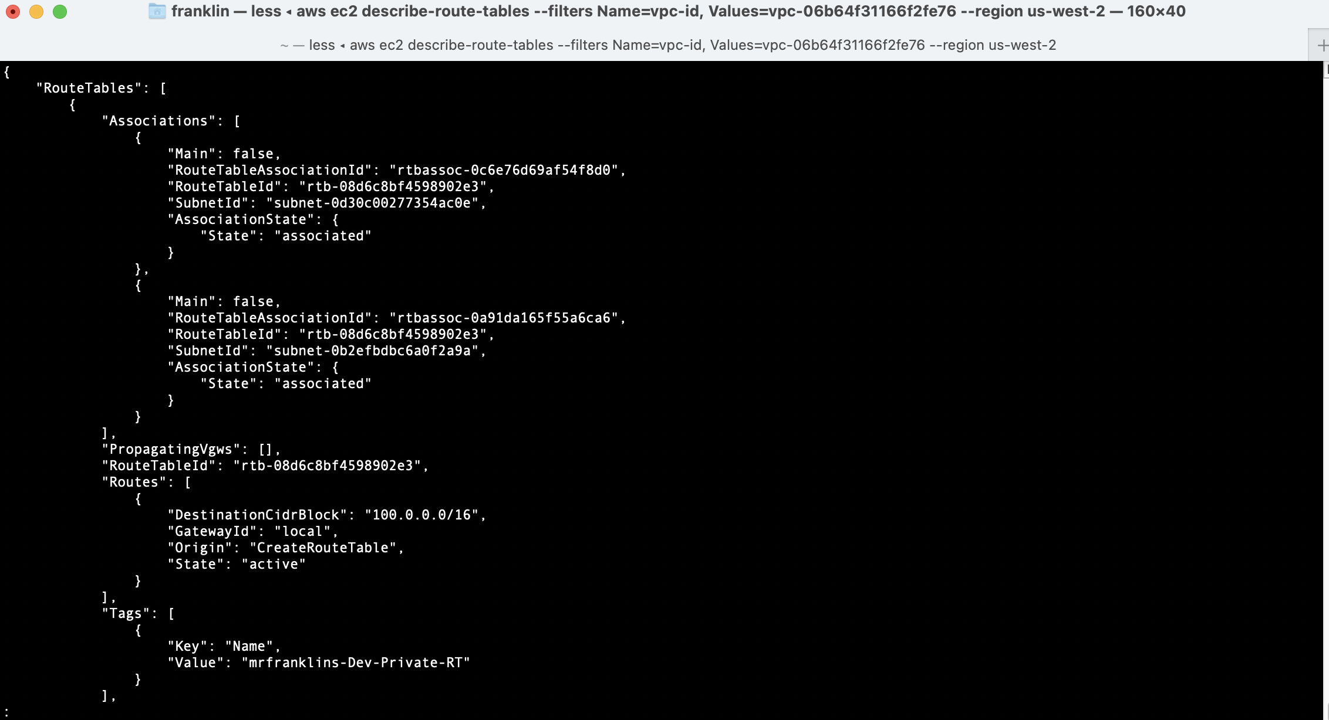

ii) ​Create a route in the route with Destination (0.0.0.0/0) and target IGW
CMD:​
aws ec2 create-route --route-table-id rtb-02229161b665fc1d1 --destination-cidr-block 0.0.0.0/0 --gateway-id igw-0ca707473d1f81a34 --region us-west-2

Output
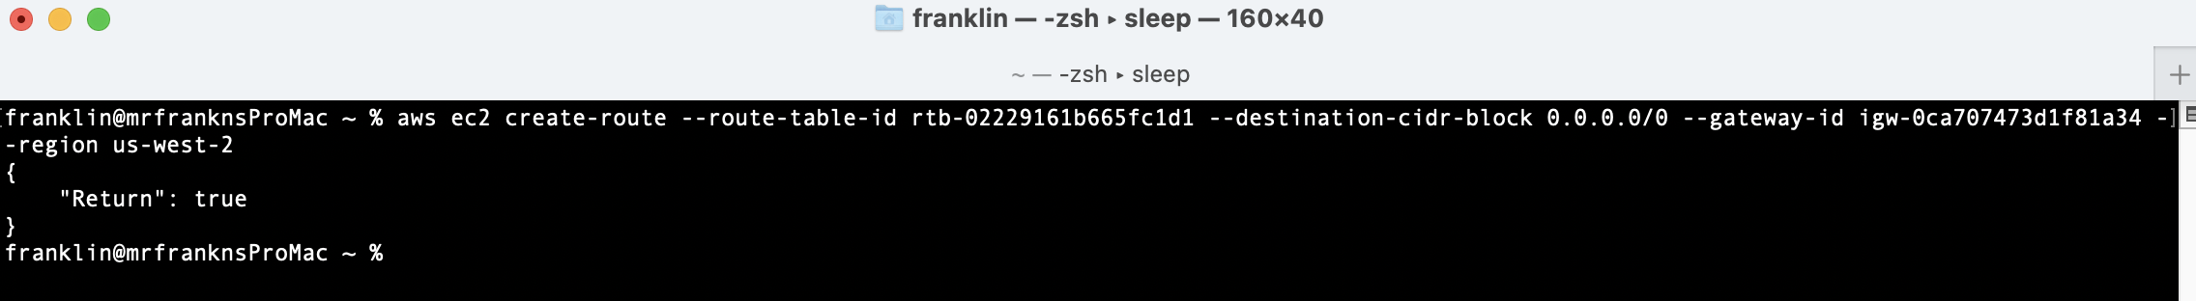
iii) Describe public route table to confirm public route was added successfully
NB: You will notice 0.0.0.0/0 has been added to the Public Route table.

CMD:​ ​
aws ec2 describe-route-tables --route-table-id rtb-02229161b665fc1d1 --region us-west-2

Output
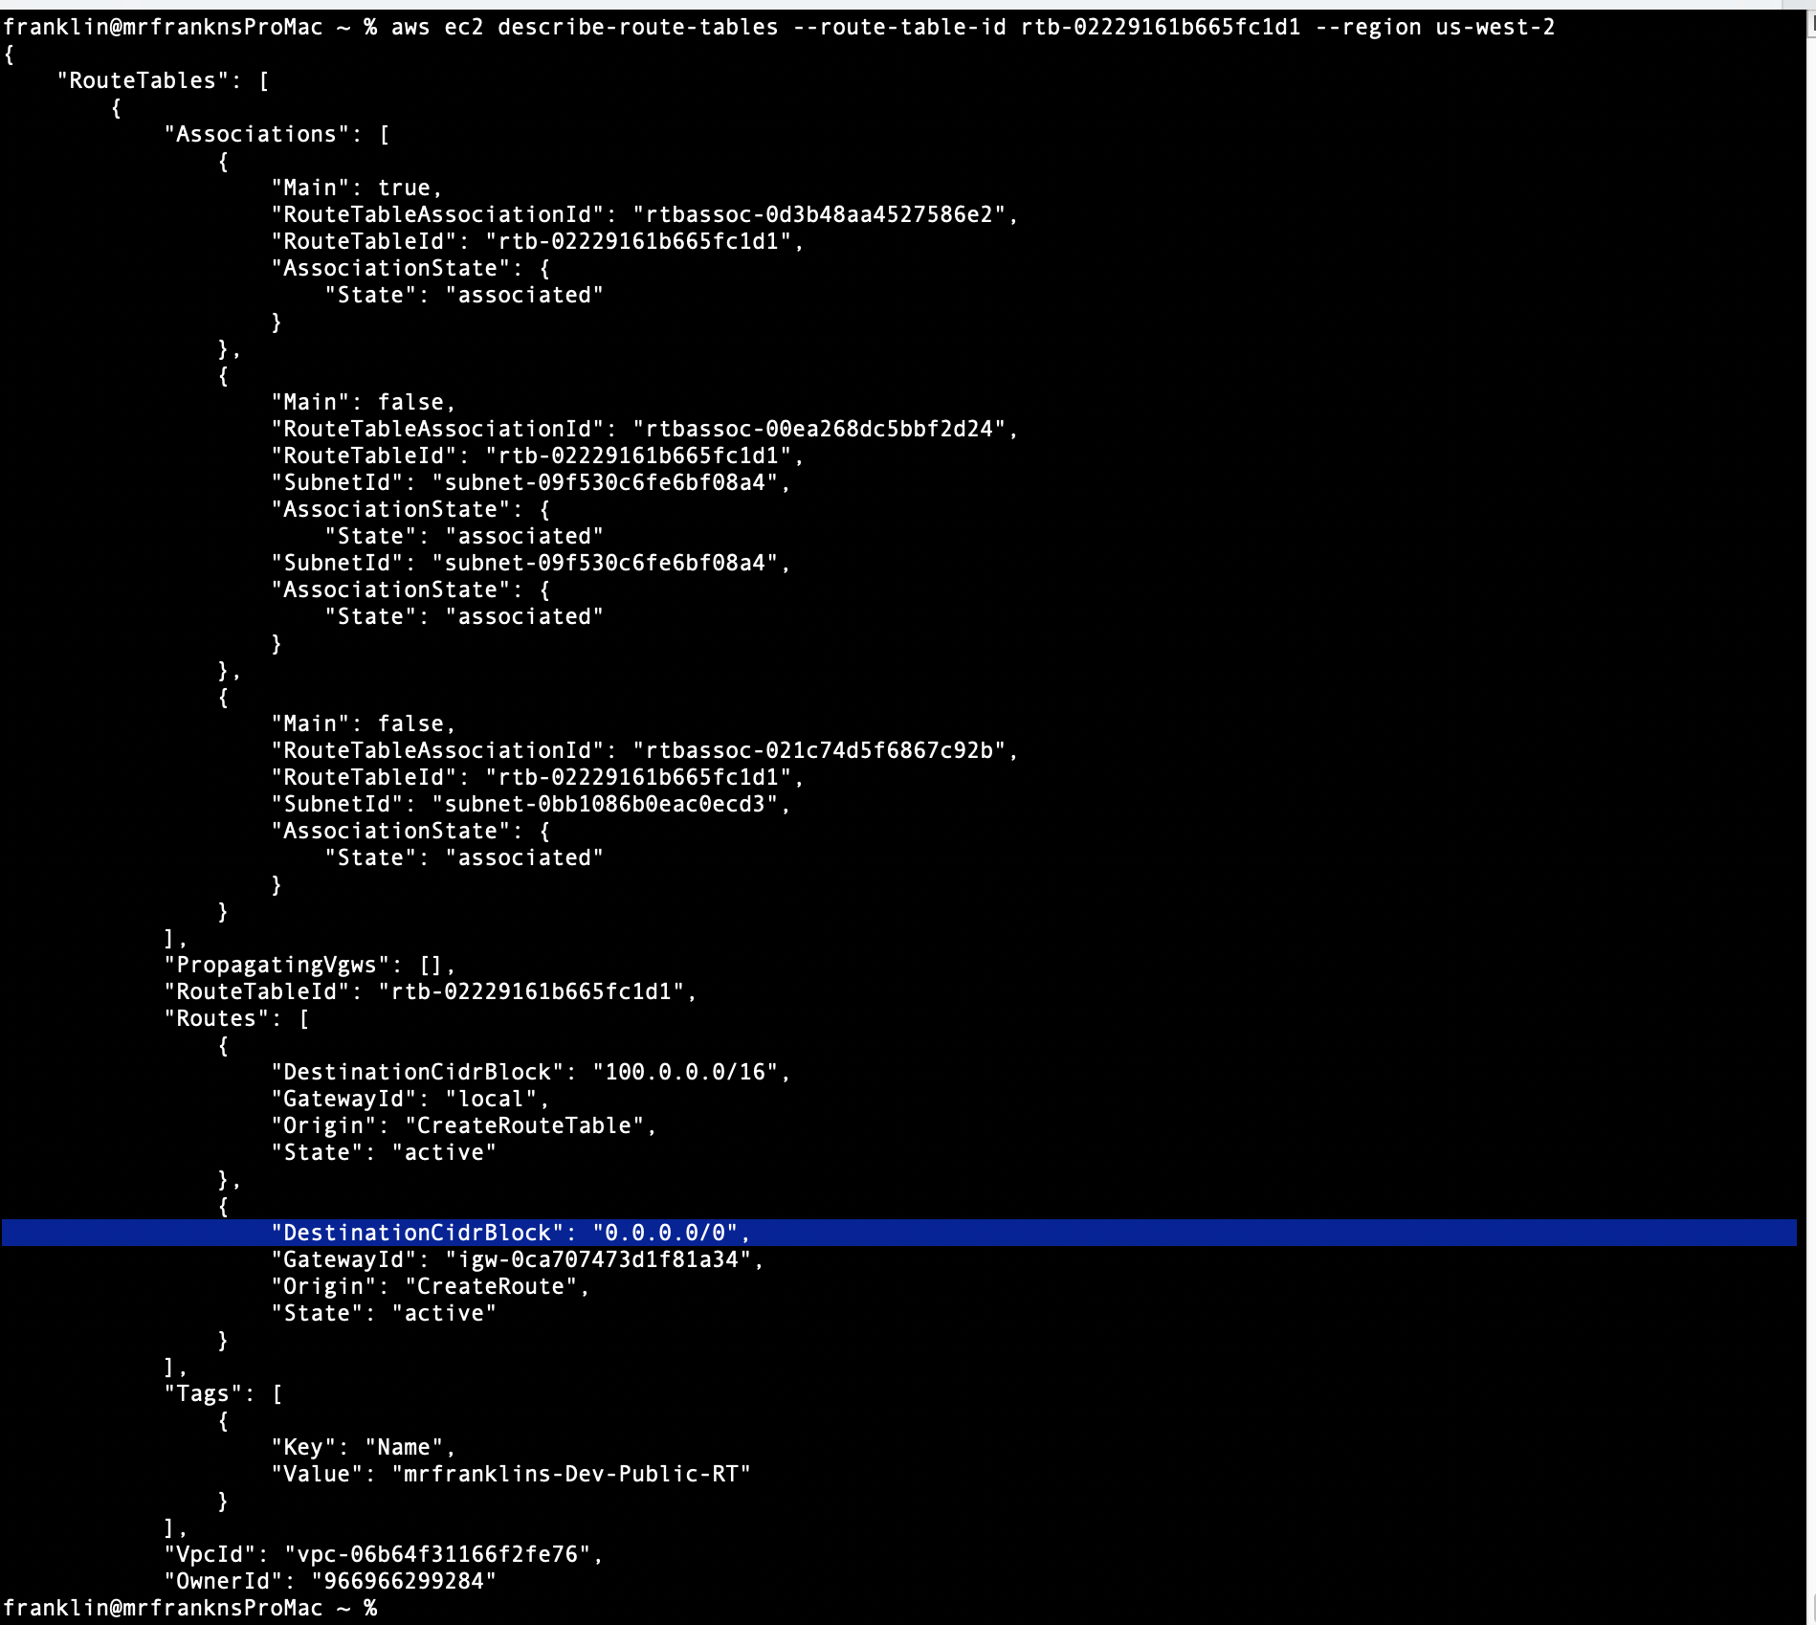
8) ​Provisioning a NAT Gateway for private subnets.
A) Create a NAT Gateway (mrfranklins-Dev-VPC-NAT). But first Create/Allocate an elastic IP address which we’ll use during the NAT creation. We need to also describe our VPC specific subnets to get the public subnet ID where we’ll place our NAT Gateway.
i) Create/Allocate an elastic IP address which we’ll use during the NAT creation.
NB: Make sure to save your Elastic IP and allocation-id

CMD:​
​aws ec2 allocate-address --region us-west-2

Output
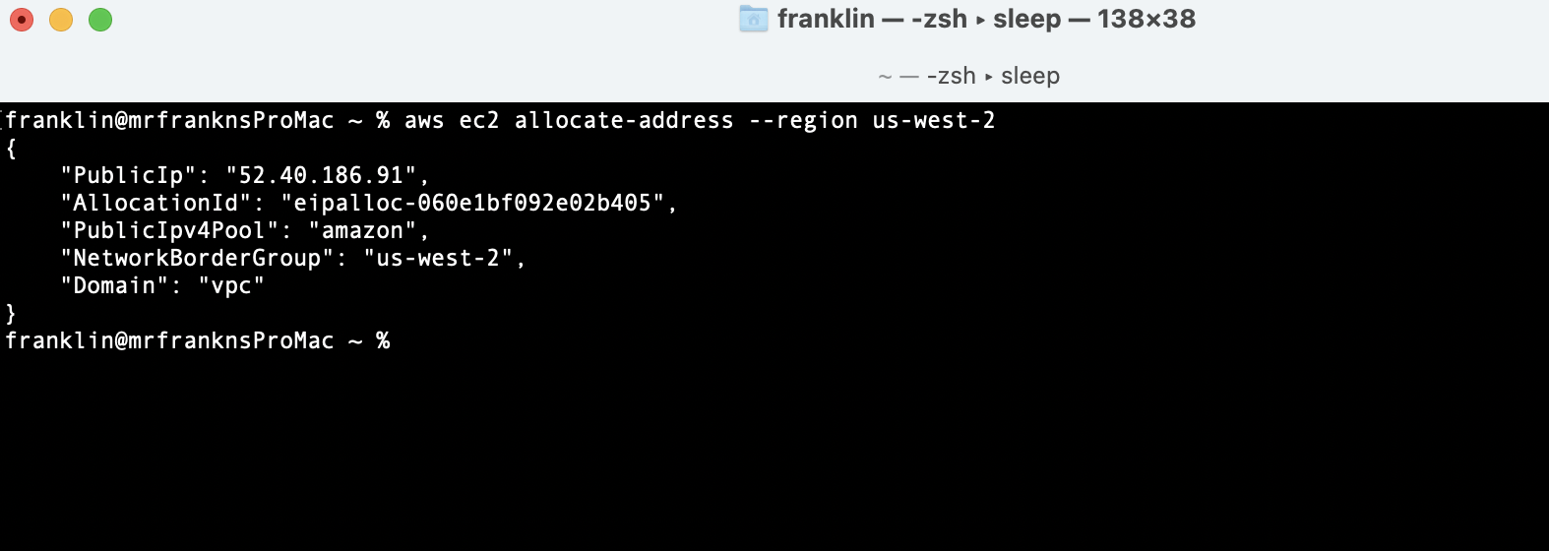

ii) We need to also describe our VPC specific subnets to get the public subnet ID where we’ll place our NAT Gateway.
CMD:
​​ aws ec2 describe-subnets --filters "Name=vpc-id, Values=vpc-06b64f31166f2fe76" --region us-west-2

Output
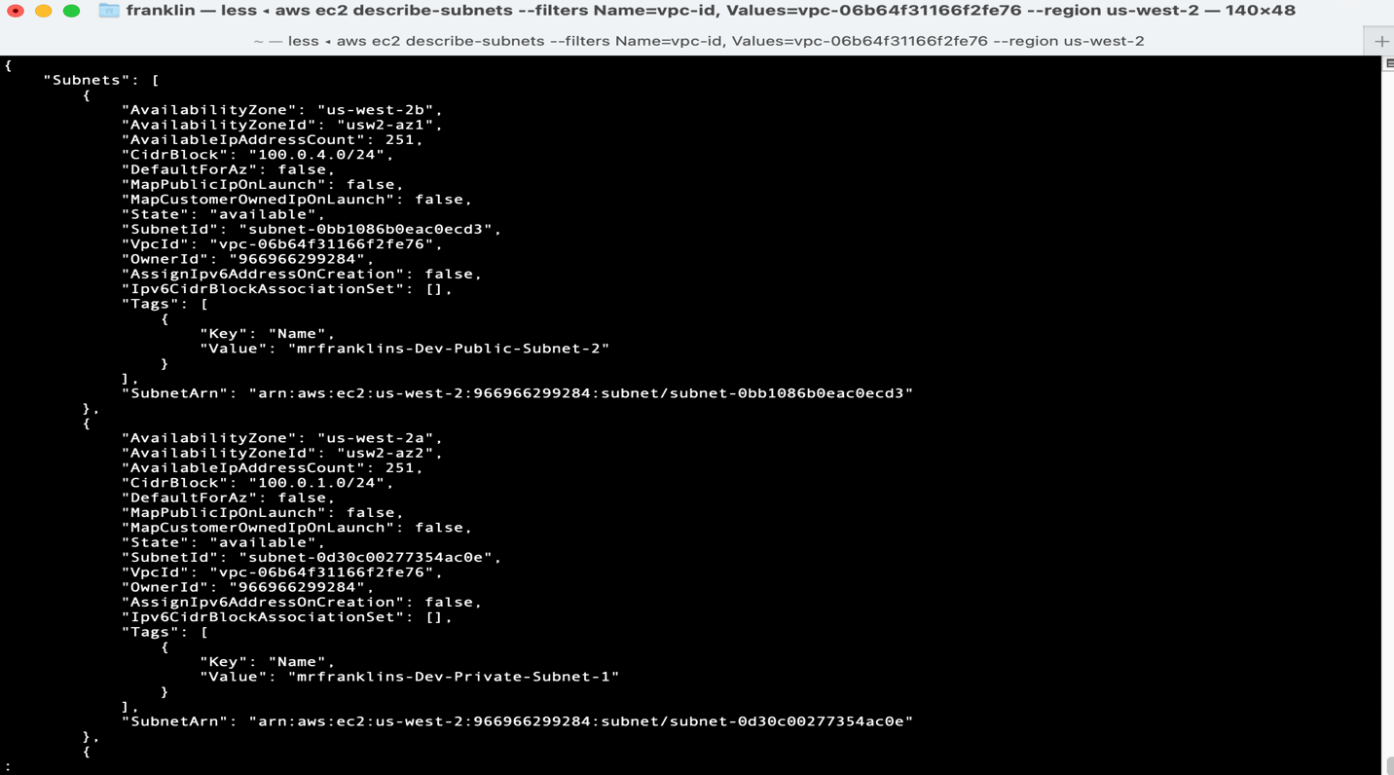
ii) Create a NAT Gateway (mrfranklins-Dev-VPC-NAT)
CMD:
​ aws ec2 create-nat-gateway --subnet-id subnet-09f530c6fe6bf08a4 --allocation-id eipalloc-060e1bf092e02b405 --tag-specifications 'ResourceType=natgateway,Tags=[{Key=Name,Value=mrfranklins-Dev-VPC-NAT}]' --region us-west-2

Output
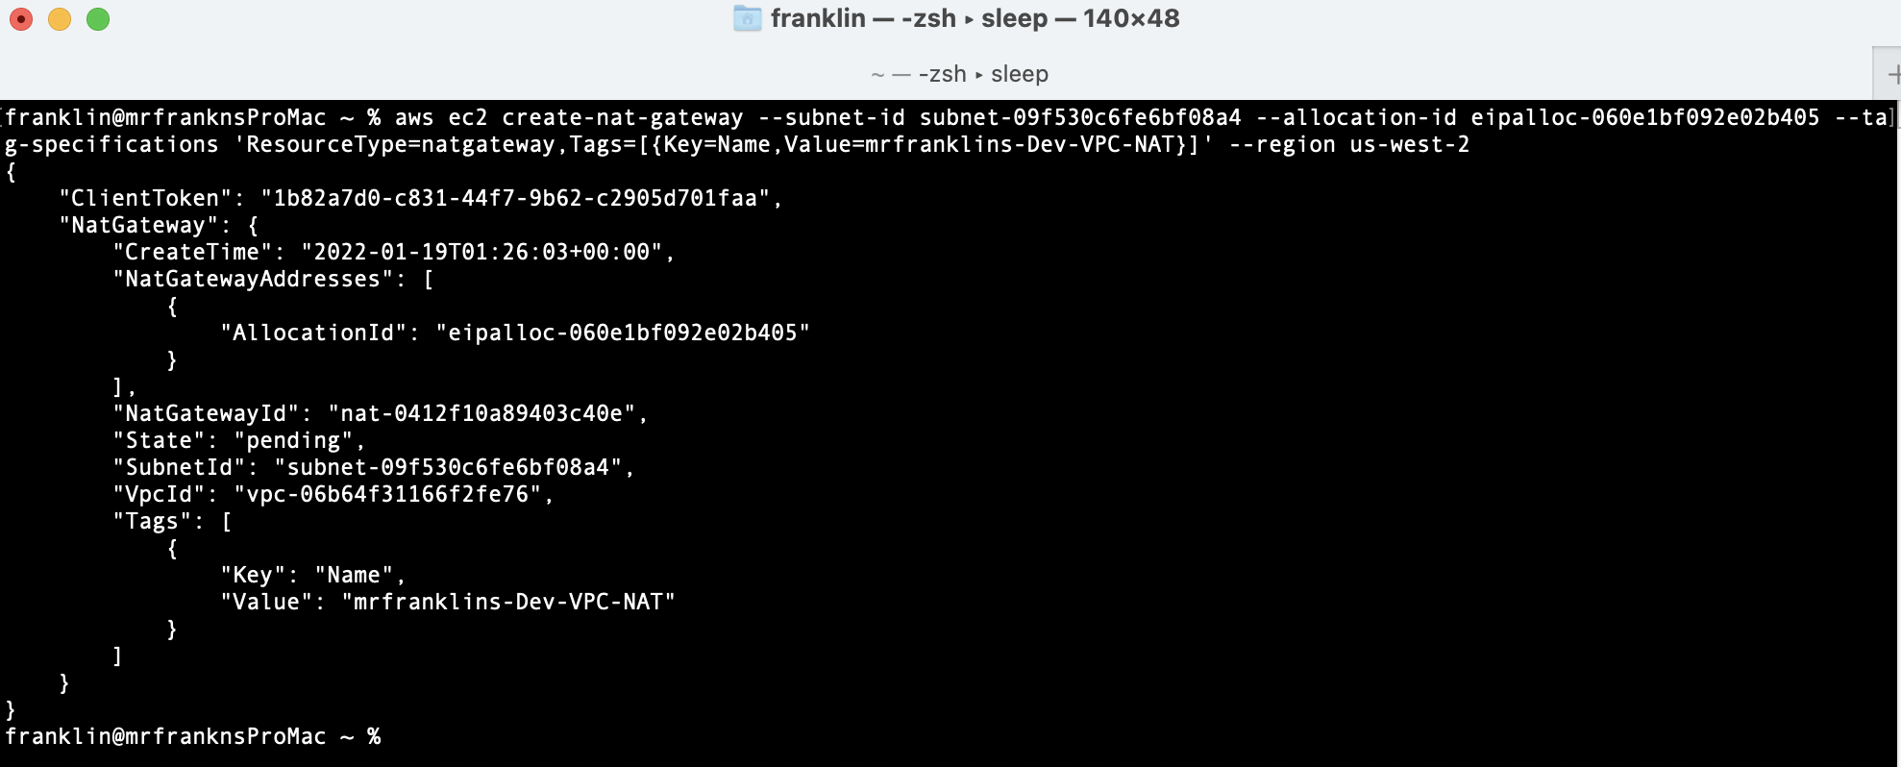

iii) Describe the NAT Gateway’s state to make sure it’s ​available​ not ​pending
CMD:​ ​
aws ec2 describe-nat-gateways --region us-west-2

Output
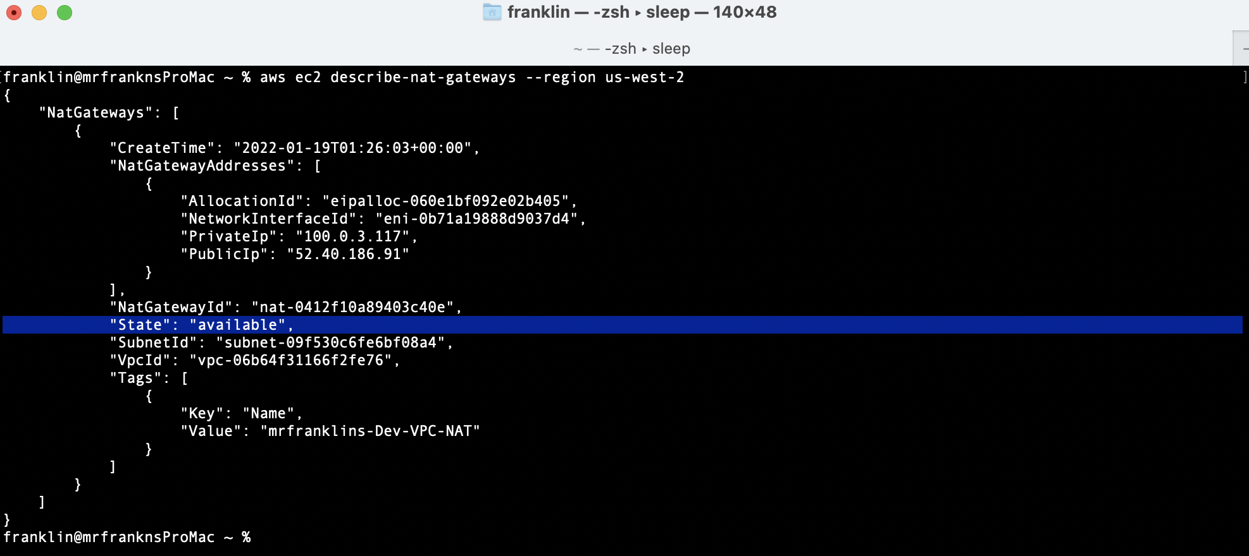
iv) We need to Create an additional route on our private route table with Destination (0.0.0.0/0) and target being the NAT Gateway. But first describe route tables to get private route table ID.
CMD:​
​aws ec2 describe-route-tables --filters "Name=vpc-id, Values=vpc-005fbf43006b6893b" --region us-west-2

Output
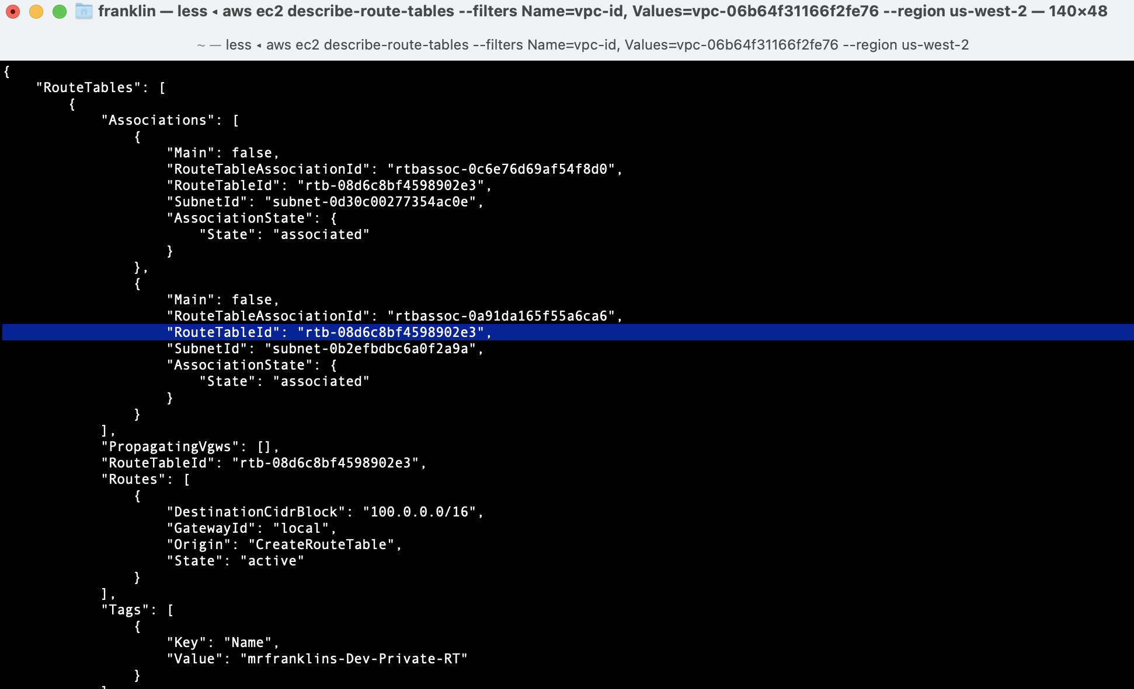

V) We need to Create an additional route on our Private route table with Destination (0.0.0.0/0) and target being the NAT Gateway.
CMD:​
​aws ec2 create-route --route-table-id rtb-08d6c8bf4598902e3 --destination-cidr-block 0.0.0.0/0 --nat-gateway-id nat-0412f10a89403c40e --region us-west-2

Output

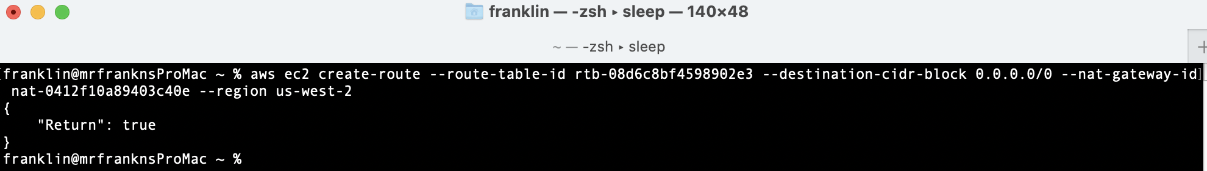
DELETE RESOURCES:

- Delete Nat Gateway
franklin@mrfranknsProMac ~ % aws ec2 delete-nat-gateway --nat-gateway-id nat-0412f10a89403c40e

- Release Elastic IP:
franklin@mrfranknsProMac ~ % aws ec2 release-address --allocation-id eipalloc-060e1bf092e02b405

- Detach Internet Gateway:
aws ec2 detach-internet-gateway --vpc-id vpc-06b64f31166f2fe76 --internet-gateway-id igw-0ca707473d1f81a34 --region us-west-2

- Delete Internet Gateway:
franklin@mrfranknsProMac ~ % aws ec2 delete-internet-gateway --internet-gateway-id igw-0ca707473d1f81a34
- Manually Disassociate Public route table via the console.
- Click on Route Table
- Choose mrfranklins-Dev-Public-RT
- Click on Subnet association
- Click on Edit subnet association
- Uncheck mrfranklins-Dev-Public-Subnet-2 and mrfranklins-Dev-Public-Subnet-1 and Save association.

- Manually Disassociate Private route table via the console.
- Click on Route Table
- Choose mrfranklins-Dev-Private-RT
- Click on Subnet association
- Click on Edit subnet association
- Uncheck mrfranklins-Dev-Private-Subnet-2 and mrfranklins-Dev-Private-Subnet-1 and Save association.

- Manually remove 0.0.0.0/0 from the public route table via the console.
- Click on Route Table
- Choose mrfranklins-Dev-Public-RT
- Click on Routes
- Click on Edit routes
- Remove 0.0.0.0/0 for IGW and save changes.

- Manually remove Nat gate from the private route table via the console.
- Click on Route Table
- Choose mrfranklins-Dev-Private-RT
- Click on Routes
- Click on Edit routes
- Remove 0.0.0.0/0 for Nat gateway and save changes.

- Delete the private and or the public route table (one of them should fail). If it fails the it is the default RT that cannot be deleted. And will be deleted when the VPC is deleted.
franklin@mrfranknsProMac ~ % aws ec2 delete-route-table --route-table-id rtb-08d6c8bf4598902e3

- Delete Subnets:
franklin@mrfranknsProMac ~ % aws ec2 delete-subnet --subnet-id subnet-0bb1086b0eac0ecd3
franklin@mrfranknsProMac ~ % aws ec2 delete-subnet --subnet-id subnet-09f530c6fe6bf08a4
franklin@mrfranknsProMac ~ % aws ec2 delete-subnet --subnet-id subnet-0b2efbdbc6a0f2a9a
franklin@mrfranknsProMac ~ % aws ec2 delete-subnet --subnet-id subnet-0d30c00277354ac0e

- Delete VPC:
franklin@mrfranknsProMac ~ % aws ec2 delete-vpc --vpc-id vpc-06b64f31166f2fe76

