Demo – S3 Cross Region Replication

========================================

**NB:**

Region Create an S3 bucket in this account. In my case I created a bucket called “mfg-test02”. This bucket will be used for replication purposes.

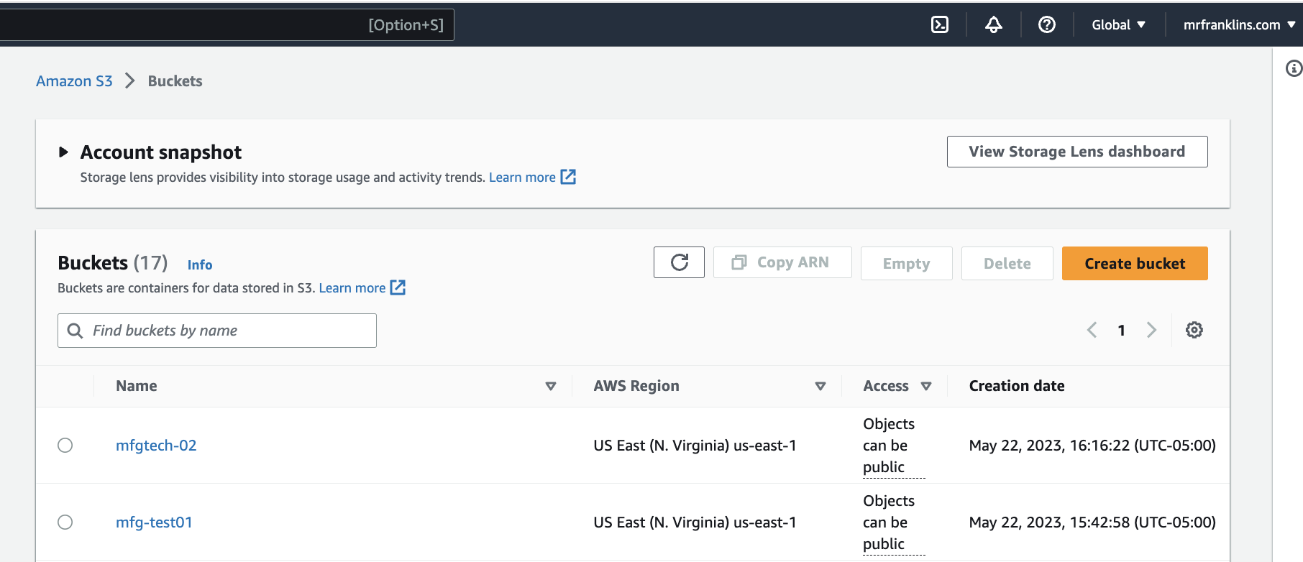

🡪 Go to the old bucket called mfgtech-01

🡪 Create Cross Region Replication:

* Go to the mfg-test01 S3 bucket
* Click on Management

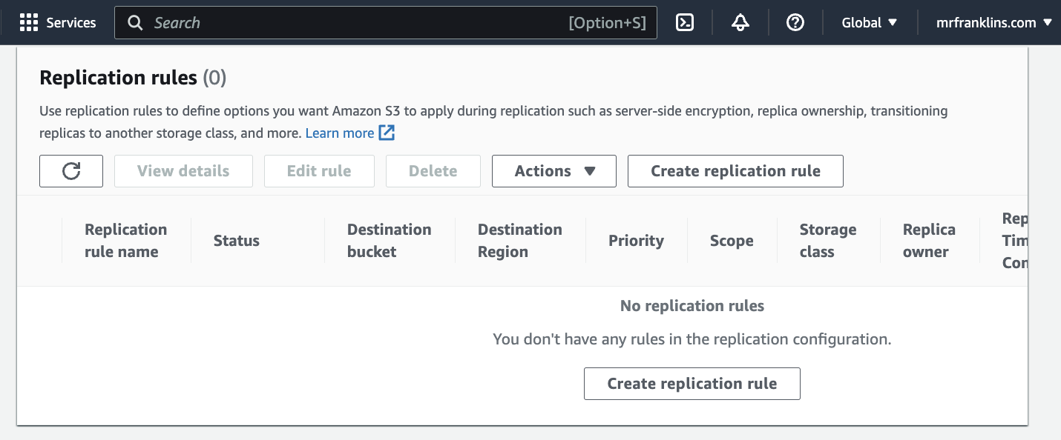

* Click on create Replication Rules
* Make sure your configurations match below configurations.

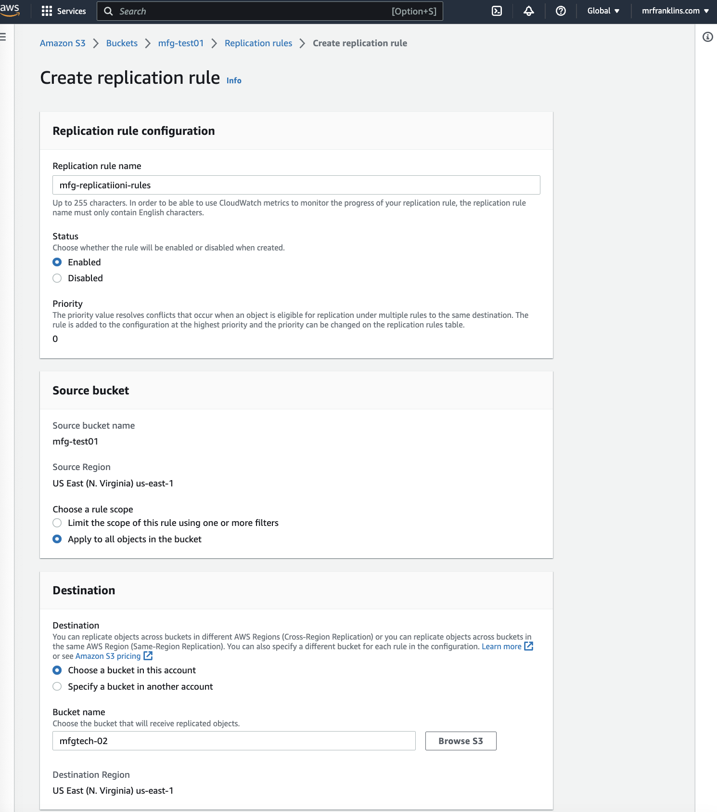

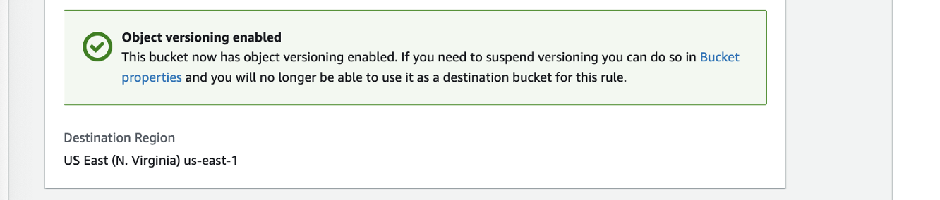

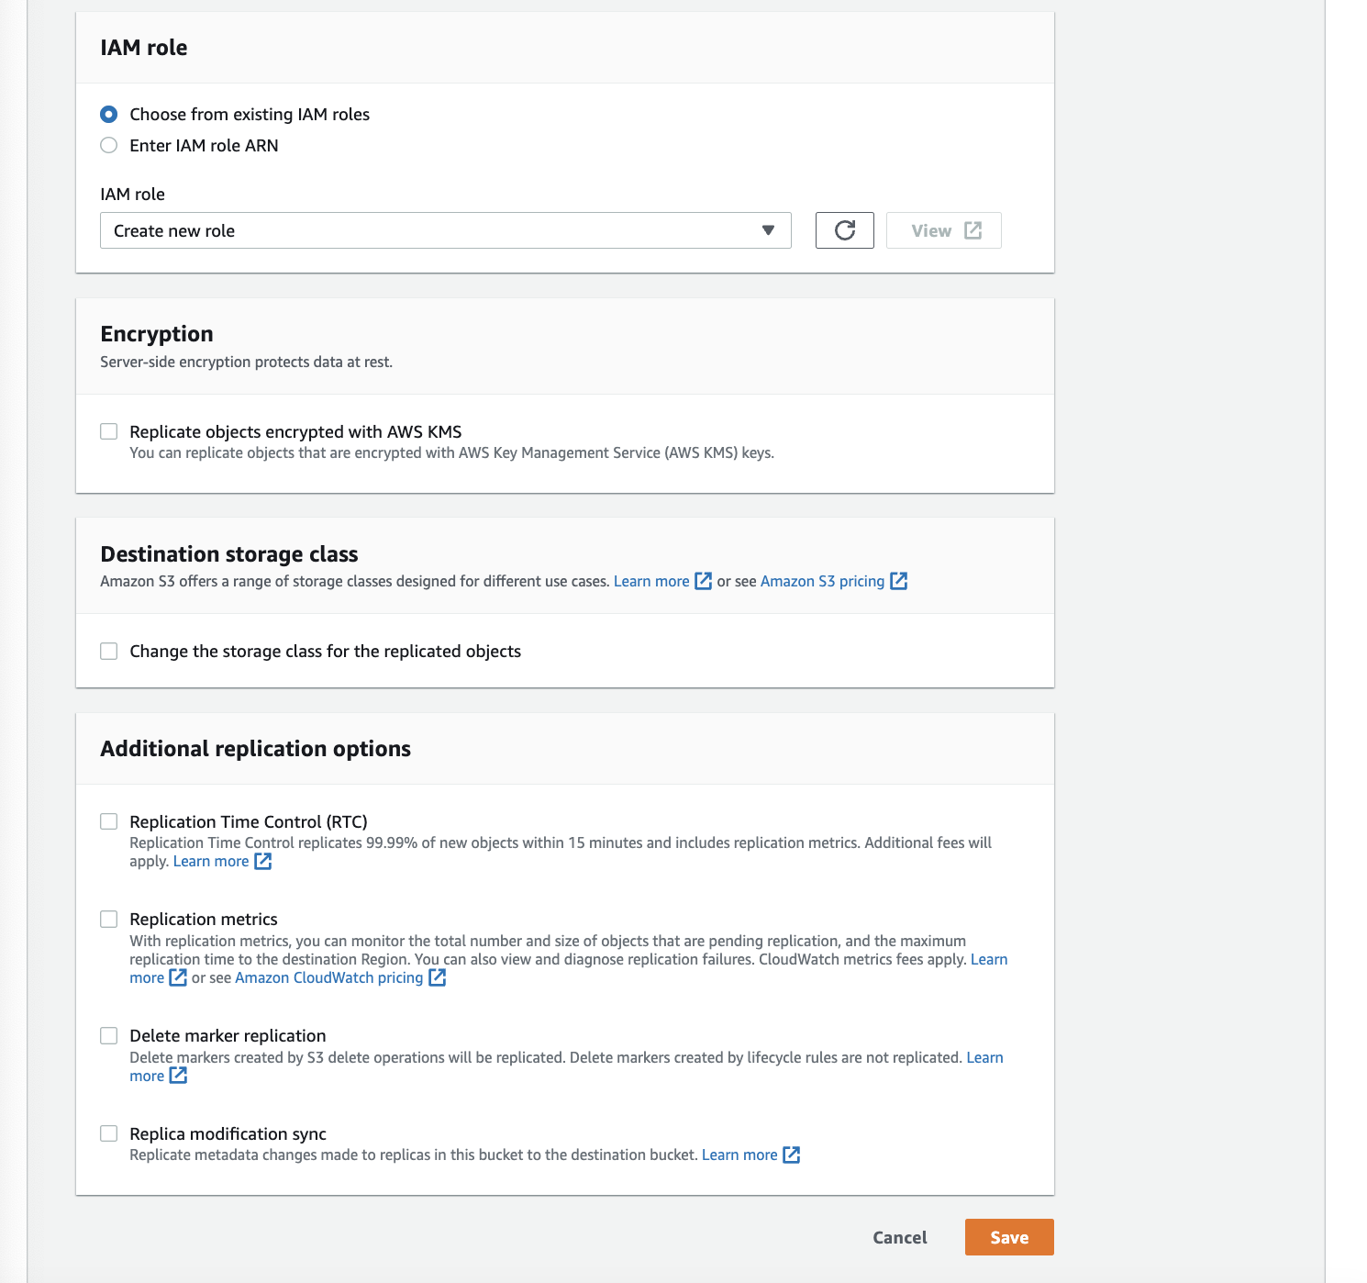

If you want your S3 objects to be replicated within 15 minutes you need to check the “Replication Time Control (RTC) box. But you will be charged for this. So, we will move forward without enabling that for now and click on save.

As soon as you click on save, a screen will pop up asking if you want to replicate existing objects in the S3 bucket. But that will incur charges so we will proceed without replicating existing objects and click on submit.

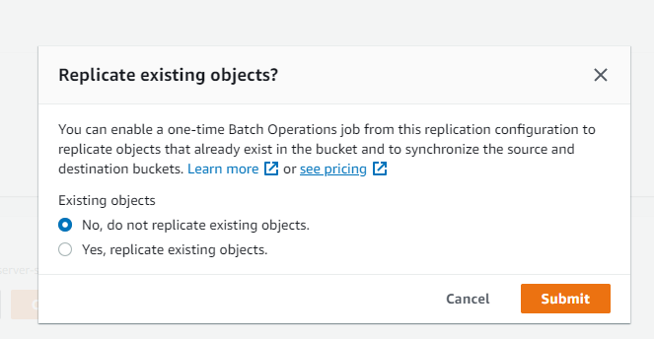

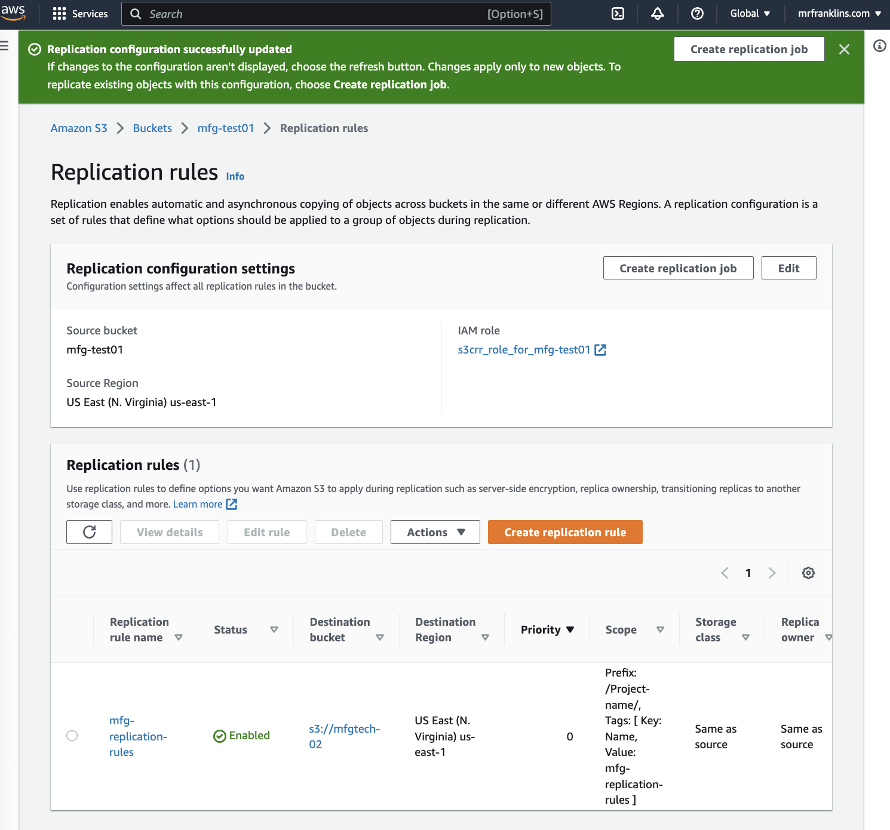

* DO NOT Create Batch Operations job

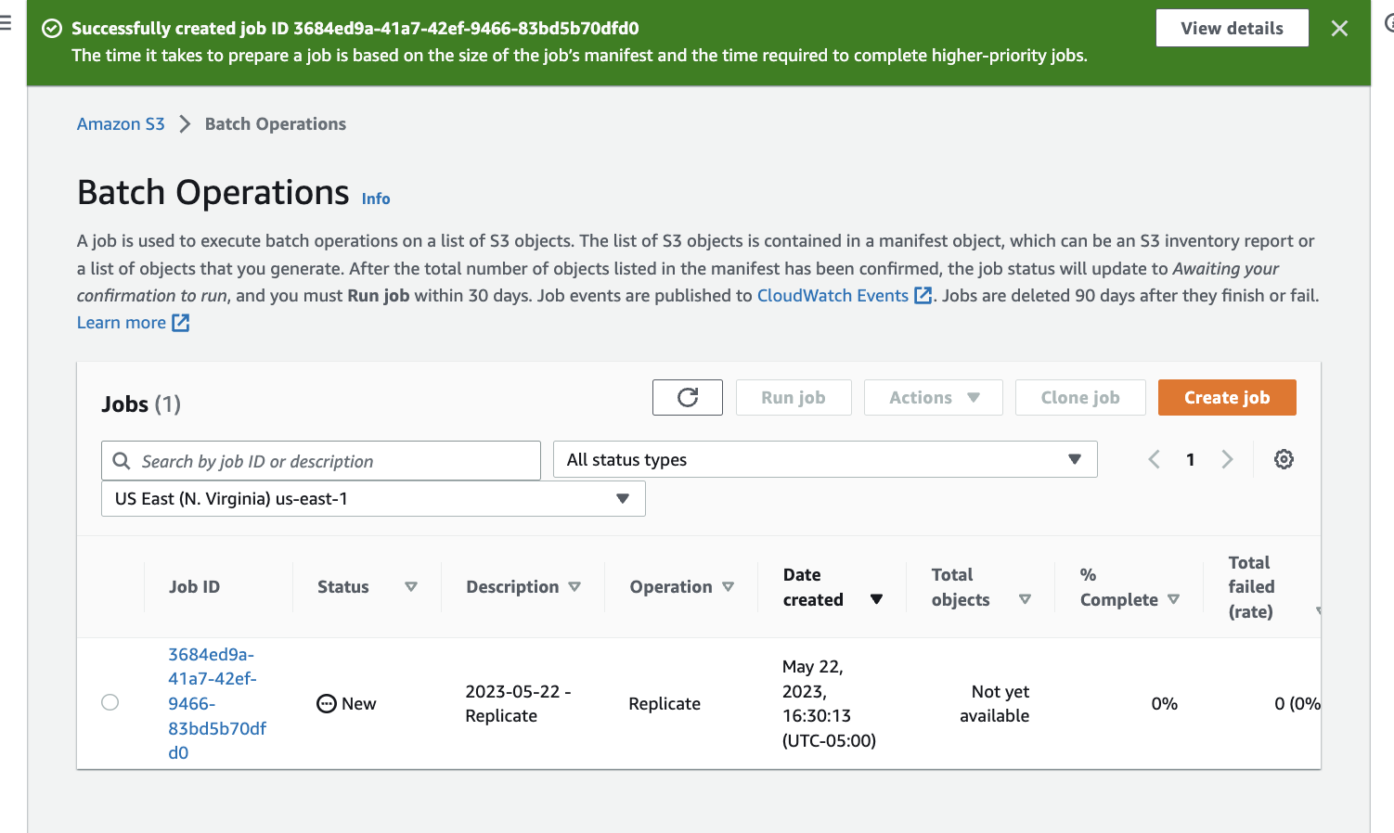

**TESTING:**

* Upload an object into the mfgtech-01 bucket. It should replication to the mfgtech-01.

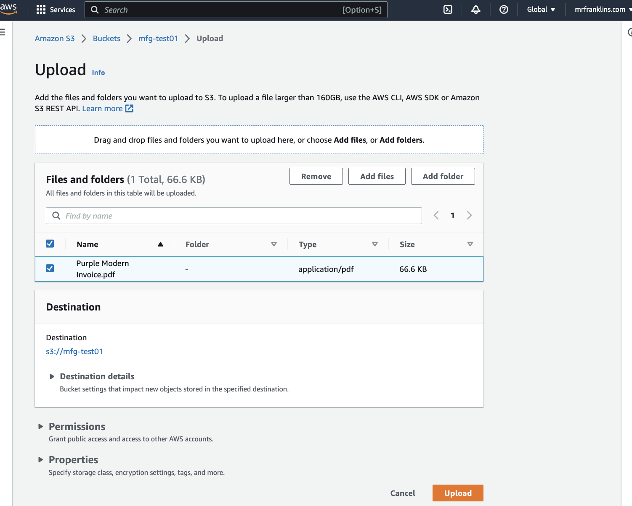

* File uploaded

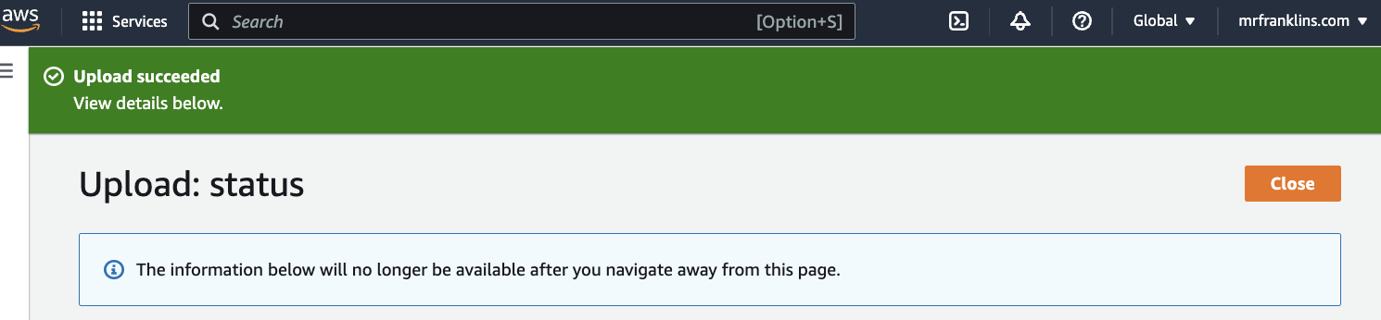

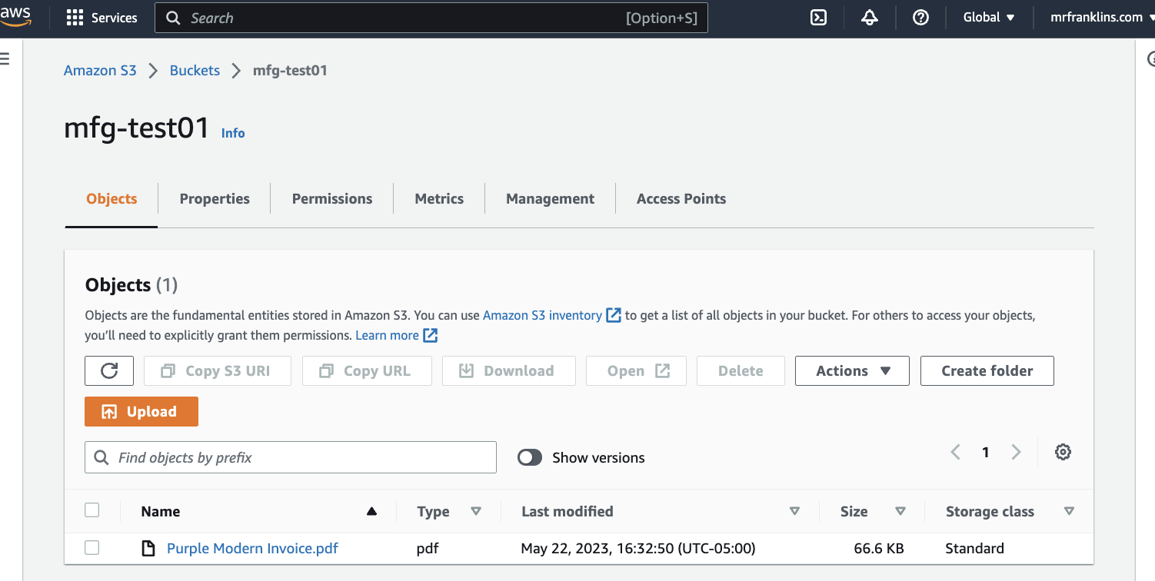

**NB:** WAIT between 5-15 minutes then;

* Go into the mfgtech-02 bucket. You should see the replicated file there.

