Demo – S3 Bucket Policies

=======================================================

**Firstly:** Create an S3 bucket

**Secondly**: Generate a bucket policy

🡪 Go to <https://awspolicygen.s3.amazonaws.com/policygen.html>

🡪 Fill out the policy document (like below)

**NB:** Make sure to add “/*” at the end of the bucket ARN.

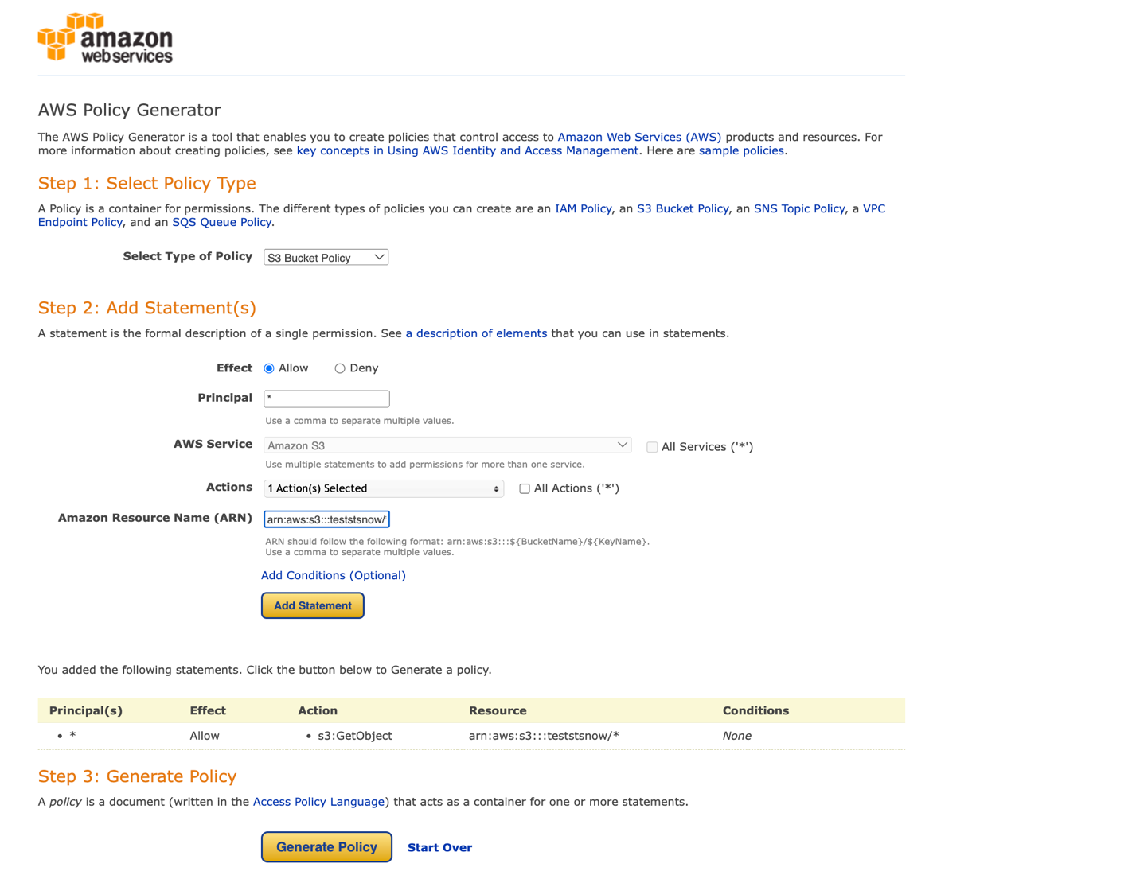

🡪 Click on Add statement then click on Generate Policy:

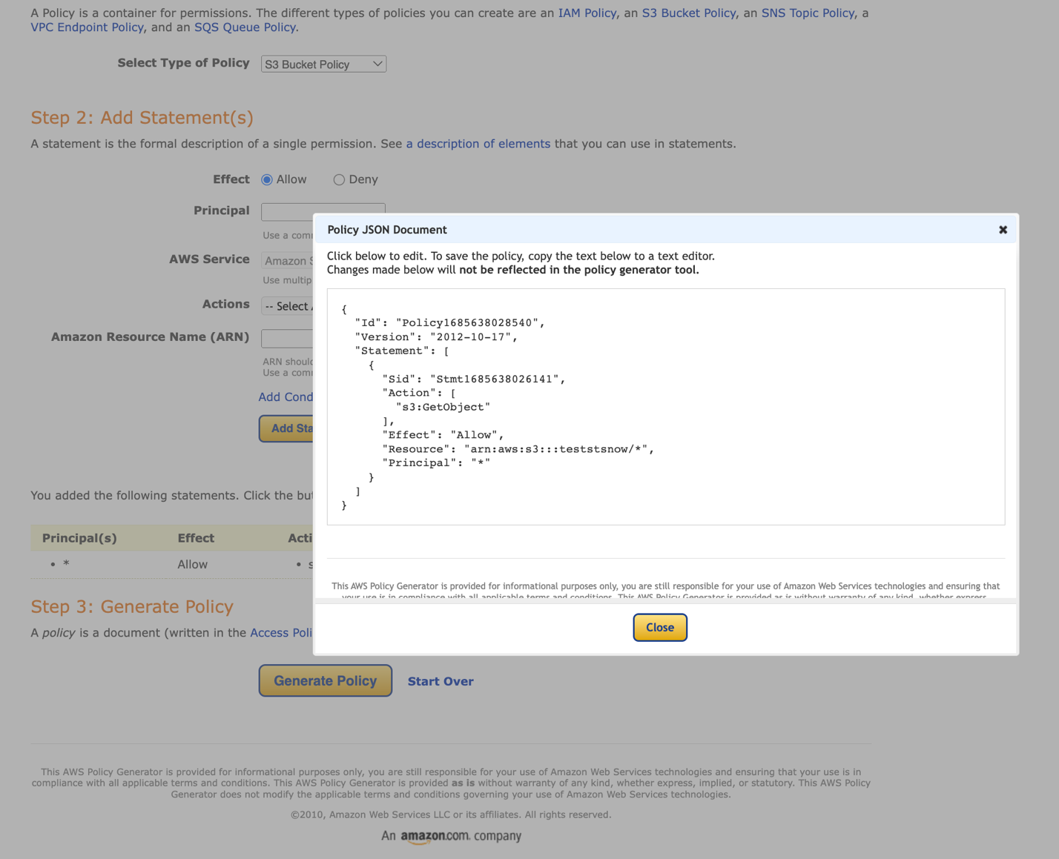

**NB:** Make sure to add “/*” at the end of the bucket ARN.

**Secondly**: Copy a bucket policy and Update S3 bucket

🡪 Go to your mfgtest01 bucket

🡪 Click on Permissions

🡪 Click on edit bucket policy

🡪 Past the copied policy (as seen below)

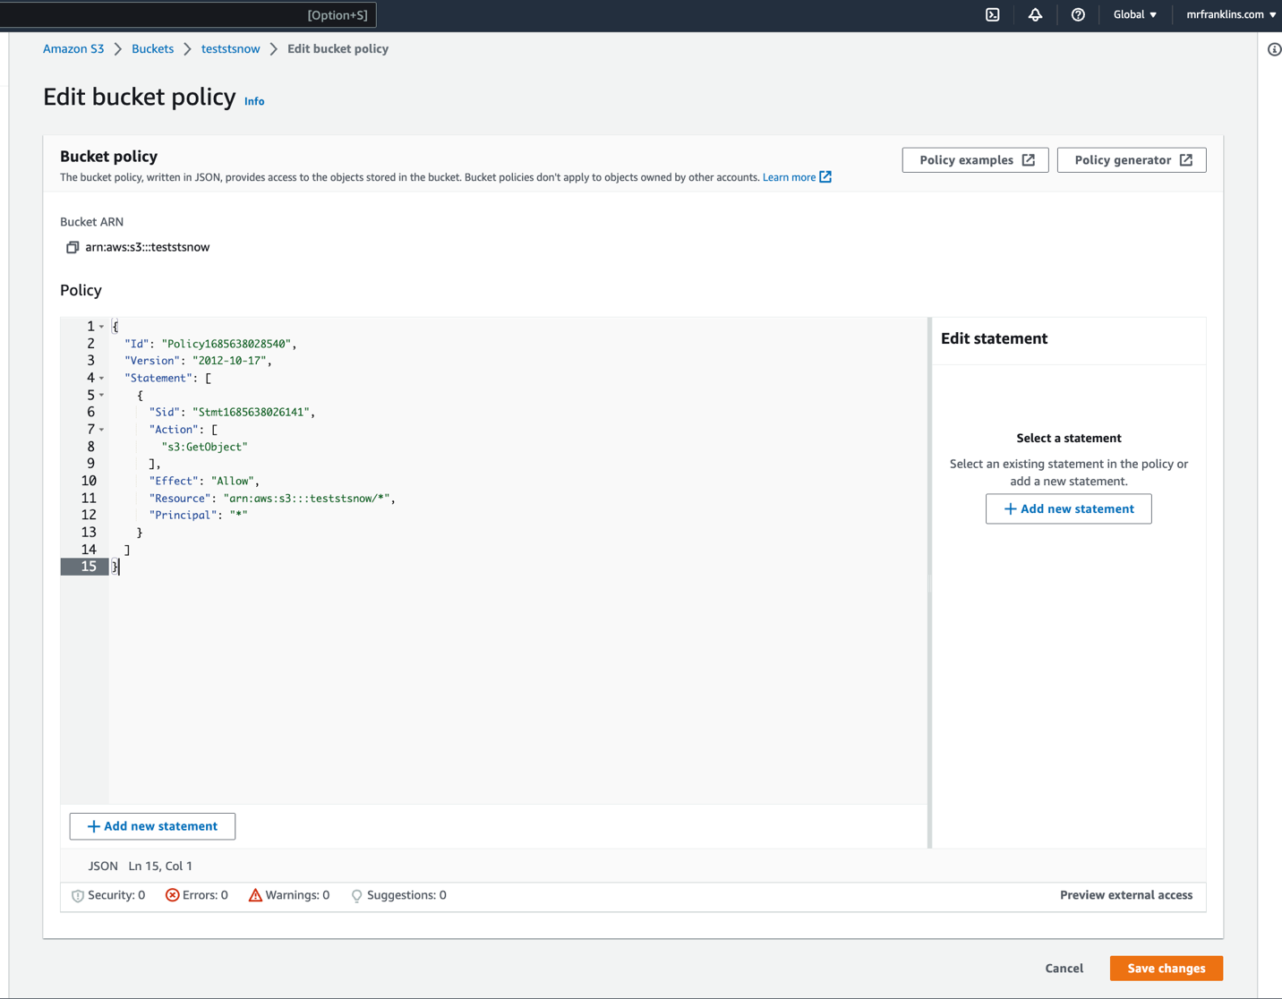

🡪 Save changes.

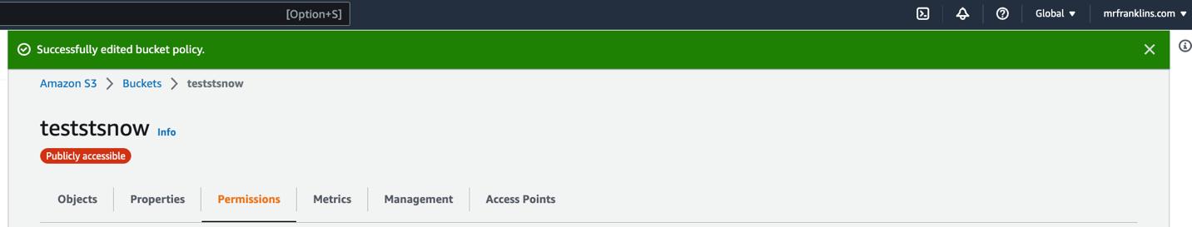

S3 Access Logs

=======================================================

Amazon S3 Server Access Logging provides detailed records for the requests that are made to a bucket. Server access logs are useful for many applications. For example, access log information can be useful in security and access audits. It can also help you learn about your customer base and understand your Amazon S3 bill.

## Amazon configuration[Permalink to this headline](https://documentation.wazuh.com/current/amazon/services/supported-services/server-access.html#amazon-configuration)

1. [Create a new](https://documentation.wazuh.com/current/amazon/services/prerequisites/S3-bucket.html) S3 bucket to store the access logs in it. If you want to use an existing one, skip this step.
2. Go to Services > Storage > S3:

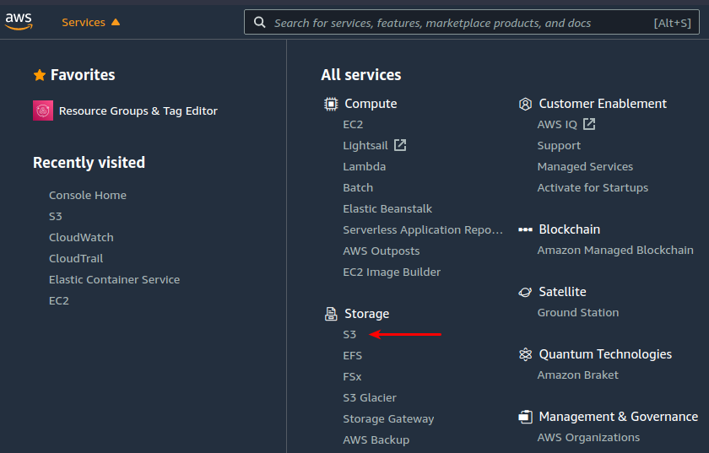

1. Look for the S3 bucket you want to monitor and click on its name:

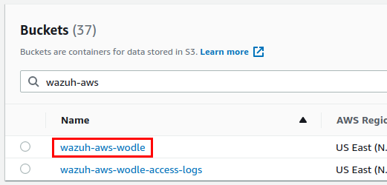

1. Go to the **Properties** tab, scroll down until you find the **Server access logging**, and click on the **Edit** button:

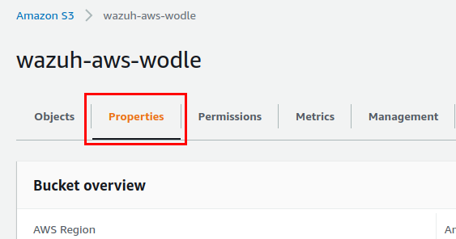

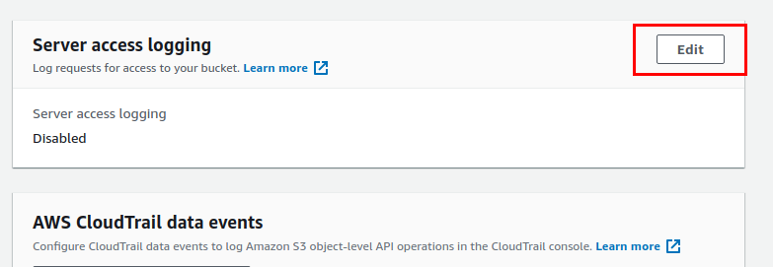

1. Check the **Enable** option, and click on the **Browse S3** button to look for the bucket in which you want S3 Server Access logs to be stored:

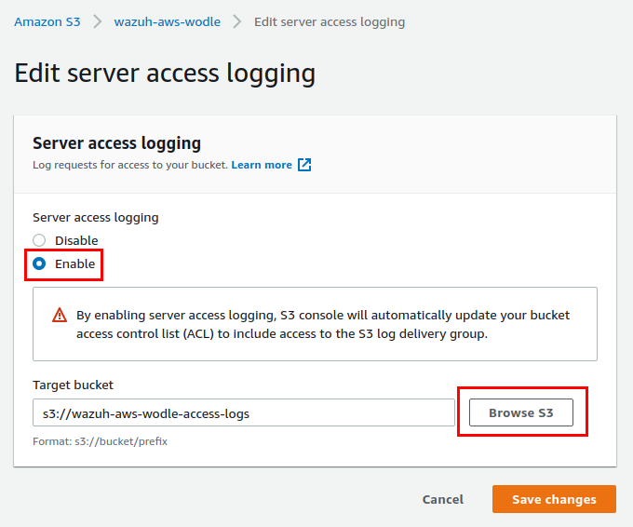

**Note**

It is possible to store the S3 Server Access logs in the same bucket to be monitored. It is also possible to specify a custom path inside the bucket to store the logs in it.

1. Finally, click on the **Save changes**. S3 Server Access logs will start to be stored in the specified path.